

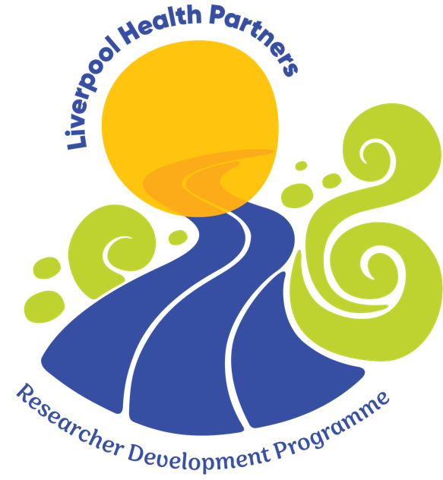
Liverpool Health Partners Researcher Development Programme (LHP RDP)

APPLICATION FORM

Please make sure you have completed all sections of the form before you submit it. We will accept neither incomplete forms nor chase up any missing information. Please ensure you attach a copy of your CV with this application.

Forms submitted after the closing date deadline of 5pm, Wednesday 30th April 2025 will not be considered so please give yourself enough time to have the relevant discussions with your line manager and senior manager to complete the form.

Electronic signatures will be accepted.

1. To be completed by the applicant. (Please word process your answers)

Personal Details
Title

First name

Last name

What is your profession?

Name of Employer/Organisation
Job Title

What is your current grade or agenda for change band?
Address for correspondence

Postcode
Contact email

Contact phone number
Professional registration if applicable. Please provide details of your professional registration including your registration number and date of registration renewal.

Special Needs or Support
Please state any support required as a consequence of any disability or medical condition

Please describe briefly your current role (max 200 words).

Application Questions (please complete all of the following questions with a maximum words per question as stated)
Please detail briefly why you wish to undertake the RDP programme and why you think you will benefit from the opportunity (300 words).

Previous Involvement in Research
Please outline any previous involvement in research (300 words)

Please provide evidence of management support for your application for this programme (100 words)

Please attach a brief CV (This should be no more than 2 A4 pages and will include current educational attainment, professional qualifications/registration where appropriate, any prior research experiences including training to date, brief summary of any publications, grants, research presentations and other information applicants consider may be relevant to this application).

3. Supporting statement from employer

Employing organisation supporting statement
Applicant’s name:

I can confirm my full support for the applicant and agree to:

Engage with the applicant to develop next steps (e.g. career developments, succession planning, project work).

Honour the commitment to allow the applicant protected time of two days per month to undertake the programme.

Discuss with the applicant the research needs of the area, department or organisation.

Keep the programme team informed of changes in circumstances that impact on the applicant’s progress.
Name (please print):
Signature of line manager: Date:
Contact telephone number:
Contact email:

Employing organisation
Signed authorisation from current employing line manager (By signing this authorisation this confirms permission to attend the Early Career Researcher Programme and matched time to enable effective participation in the programme).

Please print name of Senior Manager: ……………………………………………..

Contact email/telephone number: ………………………………………….

Signature of Senior Manager Date

Sharing of information
I confirm that I am happy for my email address to be shared amongst NHS R&D North West and LHP for the purpose of being kept up to date with future communications from the team.
Signature | Date

Declaration from applicant
I confirm that the information given on this form is true, complete and accurate and I have not withheld any information relevant to this application. I confirm that I am able to attend all dates listed in the programme outline document and I am aware that the programme requires 90% attendance minimum. I confirm that I am happy for my contact details to be shared with the LHP networks and NHS R&D Networks for future communications.
Signature | Date

The deadline for submission is 5pm, Wednesday 30th April, 2025

Please return your completed forms to leanne.gregory@researchnorthwest.nhs.uk

Equality and diversity monitoring form

Why we are asking you to complete this form.

NHS R & D North West is committed to promoting equality and eliminating unlawful discrimination, and we are aiming to achieve diversity in the range of people we involve. You do not have to answer these questions, and we understand that some of this information is personal and sensitive in nature. However, gathering this data helps us to know if we are succeeding in involving different groups of people, and to change our approach if some groups are not represented.

Data protection
The information you provide is anonymous and will not be stored with any identifying information about you. We may use anonymised statistics and data to inform discussions about improving the diversity of our patient safety partners and inclusivity of participation opportunities, but no information will be published or used in any way which allows an individual to be identified. All details are held in accordance with the Data Protection Act 1998.
The information that we are asking you to provide is informed by our duties under the Equality Act 2010, and includes information about your age, race, sex and sexual orientation.
If you would like this information in an alternative format, or would like help in completing the form, please contact us [include email address].

Equality information

1. What age group do you belong to?

☐ 18–25
☐ 26–35
☐ 36–45
☐ 46–55
☐ 56–65
☐ 65 +
☐ Prefer not to say

2. Are your day-to-day activities limited because of a health problem or disability which has lasted, or is expected to last, at least 12 months (include any problems related to old age)?

☐ Yes, limited a little
☐ Yes, limited a lot
☐ No
☐ Prefer not to say

3. If you answered ‘yes’ to question 2, please indicate your disability:

☐ Vision (eg due to blindness or partial sight)
☐ Hearing (eg due to deafness or partial hearing)
☐ Mobility, such as difficulty walking short distances, climbing stairs, lifting and carrying objects
☐ Learning, concentrating or remembering
☐ Mental health
☐ Stamina or difficulty breathing
☐ Social or behavioural issues (eg due to autism, attention deficit disorder or Asperger’s syndrome)
☐ Other impairment
☐ Prefer not to say

4. What is your ethnic group?

Choose one section from A to E, and then tick the appropriate box to indicate your ethnic group.

- White:
☐ Welsh/English/Scottish/Northern Irish/British Irish
☐ Gypsy or Irish Traveller
☐ Any other White background, please write in………………………………………….

- Mixed:
☐ White and Black Caribbean
☐ White and Black African
☐ White and Asian
☐ Any other mixed background, please write in……………………………………….....

- Asian or Asian British:

☐ Indian
☐ Pakistani
☐ Bangladeshi
☐ Chinese
☐ Any other Asian background, please write in…………………………………………..

- Black or Black British:

☐ Caribbean
☐ African
☐ Any other Black background, please write in…………………………………………..

- Other ethnic group:
☐ Arab
☐ Any other, please write in………………………………………………………………...

☐ Prefer not to say

5. What is your gender?

☐ Male
☐ Female
☐ Prefer not to say
☐ Prefer to self-identify, please write in
………………………………………..

6. Have you gone through any part of a process, or do you intend to (including thoughts or actions) to bring your physical sex appearance, and/or your gender role more in line with your gender identity? This could include changing your name, your appearance and the way you dress, taking hormones or having gender confirming surgery.

☐ Yes ☐ Prefer not to say
☐ No

7. What is your legal marital or civil partnership status?

☐ Divorced
☐ Formerly in a registered civil partnership which is now dissolved
☐ In a registered civil partnership
☐ Married
☐ Never married and never registered a civil partnership
☐ Separated, but still in a registered civil partnership
☐ Separated, but still legally married
☐ Surviving partner from a registered civil partnership
☐ Widowed
☐ Prefer not to say

8. What is your religion?

☐ No religion
☐ Atheist
☐ Buddhist
☐ Christian (including Church of England, Catholic, Protestant and all other Christian denominations)
☐ Hindu
☐ Jewish
☐ Muslim
☐ Sikh

☐ Any other religion, please write in……………………………………………………….
☐ Prefer not to say

9. Which of the following options best describes your sexual orientation?

☐ Heterosexual/straight
☐ Lesbian
☐ Gay
☐ Bisexual
☐ Prefer not to say
☐ Prefer to self-identify

10. Do you look after, or give any help or support to family members, friends, neighbours or others because of either long-term physical or mental ill-health/disability, or problems related to old age?

☐ No
☐ Yes, 1-19 hours a week
☐ Yes, 20-49 hours a week
☐Yes, 50 or more hours a week
☐ Prefer not to say

