This report evaluates the NHS R&D North West team’s “In Place ” leadership programme delivered from January to March 2018.
NHS Research & Development North West.
Report on the evaluation of “In Place” Leadership Development Programme.
June 2018
Sue Roberts
POD Learning Ltd
Table of Contents
2 Executive summary 3
2.1 Programme Aims 3
2.2 Programme Outcomes 3
2.3 What participants valued most about the programme 4
3 Introduction 5
3.1 Background 5
3.1.1 Overview of the programme 5
3.1.2 Programme aims 6
3.1.3 Participant profile 7
3.1.4 Pre-programme aims 7
4 Findings 9
4.1 Perspective of participants: 9
4.2 Perspective of team members: 10
4.2.1 Knowledge of communities of practice and ways to learn about research have increased 10
4.2.2 Levels of curiosity about innovation and research have grown 10
4.2.3 Team members feel line managers are listening more. 11
4.2.4 More team members feel their team is able to perform to the best of its ability? 12
5 Evaluation themes 13
5.1 Post programme outcomes for participants 13
5.1.1 Increased confidence 13
5.1.2 Developing the use of communication and social media to reach a wider audience 13
5.1.3 Greater leadership capability 13
5.1.4 Enhanced understanding of research and capacity to use this within their service 13
5.1.5 Development of peer network through face to face and virtual media 13
5.1.6 Strategies to take teams or service forward 14
5.2 Programme impact on team perspectives and behaviour 14
5.2.1 Leadership behaviour demonstrates greater listening which may already be impacting on improvements in team performance 14
5.2.2 Predicted increase in research activity in the future 15
5.3 What participants valued about the programme 15
5.3.1 Innovative approach 15
5.3.2 Opportunity to network with other professionals 15
5.3.3 Personal reflection 15
5.4 What got in the way of the participants learning effectively 16
5.5 Future programme improvements 16
6 Conclusion 17
7 Acknowledgements 18
8 Appendix One - Overview of the programme 19
9 Appendix Two Participant list 20
10 Appendix Three. Poem by Paul Spencer, participant as part of final presentation. (published with permission) 21
11 Appendix Four. Team evaluation results not shown in main report. 23
12 Appendix Five. Interview questions for participants. 25

Executive summary
This report evaluates the NHS R&D NW ‘In Place’ leadership development programme which ran from January to March 2018. The report demonstrates clear benefits and substantial outcomes for the participants involved in the research, summarised below.
This innovative leadership development programme used creative experiential learning to look at research agendas and leadership skills and introduced participants to virtual media such as twitter and What’s App to network with their colleagues and disseminate research findings/engage in discussion with wider audiences.
There was a total of 121 respondents to a pre-programme online questionnaire, with 39 respondents in the post-programme online questionnaire. Responses were gathered from both participants and their teams to gauge impact of the programme on teams and services. Four participants also participated in telephone interviews. This report summarises the main findings from the surveys and interviews and identifies the key outcomes.

Programme Aims
The programme aimed to work with 25 middle managers from a range of clinical backgrounds to support them in leading a culture of research and innovation by building their leadership capacity to develop the skills and confidence to create an effective culture within their units, wards/departments.

Programme Outcomes
25 managers were selected from 28 applicants. 24 of these managers completed the programme, with one dropping out due to personal reasons. The outcomes are discussed in detail within the report in section five. Participants were asked to self-score on a number of aspects of their knowledge and leadership which are listed below. The scores increased in all 7 areas.

- Knowledge and understanding of national, regional and organisational R&I agendas.
- Understanding of how organisational cultures form and the part leadership plays in this?
- Understanding of communities of practice and the benefits of being part of this?
- Knowing how to lead an effective team based on the work of Professor Michael West.
- Current level of confidence to facilitate and lead cultures of R&I.
- Your current level of ‘creativity’ in leading cultures of R&I.
- Your ability to be curious and open to new ideas and ready to embrace health innovations.

These outcomes can be summarised as:
- Increased confidence to lead others, be more innovative and engage in research
- Developing the use of communication and social media to reach a wider audience – particularly in the use of twitter and What’s App to disseminate information and ideas and connect with a wider audience.
- Greater leadership capability – this was reported both by participants and through team member evaluation, especially in how much they felt their managers now listened to them more and had developed their interest in research.
- Enhanced understanding of research and capacity to use this within their service – for both participants and their teams. Since the programme, it appears that teams have become more aware of communities of practice and how to learn about research, with the percentage who knew nothing dropped from 71.4% to 22.2%.
- Development of peer network through face to face and virtual media – participants reported learning much from their colleagues and appreciating the wider network they now have as a result of attending the course.
- Strategies to take teams or service forward – One participant talked about having a department vision for the first time, another described how they felt more confident in their leadership because they had developed a strategy to go forward. Below is an extract from a poem that one participant, Paul Spencer wrote and read out at the final day to explain his learning and action plan/strategy to move his service forward. (see appendix three for the full text.)
This is a plan of action
Enable research, overcome distraction
Four simple lines in complex times
Focusing, inspiring minds;

Educate,
Collaborate,
Initiate,
Disseminate.

What participants valued most about the programme
Participants valued highly the innovative approach which moved them “out of their comfort zone” as one participant described. The residential start with a mystery bus ride was a highlight for many, with it encouraging them to get to know one another and to have an open and curious mind to what might lay ahead. The use of creative media was novel and also helped to engage the participants according to those interviewed. Sarah Reynolds commented that the programme was “varied, memorable and different.” Participants valued time and space to think and to reflect. For Elaine Fillingham, the residential was when she realised:
“the world kept turning when I was away for two days and I need to make more time to look after myself.”
This evaluation has found very few suggestions for development or improvement, with the main one being to ensure participants understand the link between experiential activity and leadership/research.

Introduction
This report evaluates the three-module programme of “In Place” leadership development programme run by NHS R&D NW starting on 25th January 2018 for a two day residential ending on 22nd March. This programme was funded by NHS Leadership Academy ‘In Place’ Leadership Innovation.
The programme was evaluated with a pre-programme questionnaire for participants and team members, and then with a post programme online survey for both participants and their teams and telephone interviews with a random sample of 20% of the participants.
19 of the participants answered the pre-programme questionnaire, with 102 team members responding before the course. The post programme evaluation survey was completed by 8 participants and 31 team members.
The purpose of the report is to offer insight into the benefits and impact that the programme had on participants and to identify any areas for improvement for future programmes.
It is derived from both the pre and post survey results and the interviews conducted with 4 participants. 4 participants were interviewed via telephone using a semi-structured interview with an external researcher. (The questions forming the basis of the interviews are in appendix five.)

Background
This project was based primarily on two previous programmes of work delivered and evaluated by NHS Research & Development North West.
It aimed to combine the "leading clinical teams" programme funded by Health Education England4 from 2013-2016 and the Academy of Creative Minds an immersive programme for health researchers and professionals to work with creative artists to learn how to communicate their work more effectively and help increase its impact. Participants from these programmes demonstrated increased knowledge, confidence and understanding of the research landscape and culture and how to lead more effectively.
The project was led by leadership professionals, R&D professionals, creative writers, actors and performers who together worked with middle managers in a blended learning approach. All of the participants had to apply for a place on the programme.

Overview of the programme
NHS R&D NW worked creatively with 25 middle managers from a range of clinical backgrounds to support them in leading a culture of research and innovation by building their leadership capacity to develop the skills and confidence to create an effective culture within their units, wards/departments. The focus of the training explored research and innovation culture specifically because previous research has identified that organisations that are more research active have better outcomes
This project design was informed by the domains of the Healthcare Leadership Model2 and by the evaluation of the NHS R&D NW Academy of Creative Minds which was developed for the dissemination of health research but showed participation led to significant increase in individual levels of confidence, creativity and self belief3, skills essential to good leadership.
NHS R&D NW has identified a strong commitment from service managers to the integration of research and innovation into their teams but also found limitations in knowledge regarding the research and innovation policy agendas and lack of personal confidence in providing leadership in this area.4 Middle management influence is crucial to a whole systems talent management strategy. Managing, nurturing and keeping staff engaged and motivated is key to an organisation’s ability to provide high-quality care.
The Five Year Forward view is committed to research and wants to accelerate useful health innovation and speed up the adoption of cost effective innovation. All three STPS in the North West also recognise that to make the changes they want in the health of their populations they need to embrace innovation, evidence and proven best practice to shape services. To do this there is a need for a culture of research and innovation in health organisations and middle managers that have the skills and confidence to invest locally and grow a culture that embraces it.
The “Leading Cultures of Research & Innovation” project offered a novel and innovative programme of leadership development informed by NHS R&D NW stakeholder engagement and the overarching plans of the STPS and the 5 year Forward view.
The ‘In Place’ leadership programme built on the success and learning from this to deliver a more creative and engaging programme using an experiential approach with artists and also using an online medium in the form of “What’s App” to create a virtual community for sharing ideas, best practice and offering support to each other. Participants were also encouraged to complete a reflective diary. Eight weeks after the programme had completed, participants were sent a letter they had written to themselves whilst on the course to remind them of the commitments they made.
For a full copy of the module context please see appendix one
https://www.nihr.ac.uk/news/research-active-trusts-have-better-patient-outcomes-study-shows/2715
2(http://www.leadershipacademy.nhs.uk/resources/healthcare-leadership-model/
3 http://research.northwest.nhs.uk/work/academy-of-creative-minds/
4 A full report of this work can be found at http://www.research.northwest.nhs.uk/wp-content/uploads/2014/05/Joint-RI-Event-Oct-2013-Evaluation-Report.pdf
5 http://research.northwest.nhs.uk/publication_list/page/2/
6 Michael A. West, 2012, Effective Teamwork: Practical Lessons from Organizational Research (Psychology of Work and Organizations), Third Edition, BPS Blackwell.

Programme aims
The programme aimed to help participants:-
- Develop knowledge & understanding of national, regional and organisational R&I agendas
- Explore and increase individual understanding of how organisational cultures are formed and shaped by leaders
- Explore and develop skills and expertise to improve confidence and creativity to facilitate and lead cultures of R&I
- Have the opportunity to develop and benefit from a community of practice within their health economy
- Know how to lead an effective team based on the work of Professor Michael West.6
- Explore how digital technology can enable communication and support healthy communities and culture within their working environment.
- Be open to new ideas and ready to embrace health innovations.

Participant profile
Participants had to go through an application process with a cap at 25 participants. There were 28 applications, of which 25 were selected. 24 participants completed the programme, with one dropping out through personal reasons.
They came from a diverse range of expertise and roles, with middle management responsibilities. The full participant list is in Appendix two.
Before the event, the participants and their teams were asked to complete an online questionnaire which gave an indication of their aims for attending the programme as well as their perceived current level of knowledge in several areas.

Pre-programme aims
Participants reported a variety of reasons for attending. These can be grouped into the following themes:

Personal Development
- To develop confidence. For one participant this was about coming back into her role after maternity and understanding how she balanced her professional and personal life.
- To find direction re-evaluate whether the participants current role was still right.

Research knowledge and practice
- To develop knowledge regarding using research in their practice
- To be able to better evidence current and future practice and outcomes. One participant reported that their service needed to better evidence what they do and wanted to learn how to do this.

Develop Leadership capability
- To develop leadership skills. Al participants wanted to further understand and develop their leadership capability. Many had recently changed roles and taken on more responsibility and this was a good opportunity to set themselves aims for how they take their leadership forward.
- To reassure current practice as well as develop going forward.

Develop networks
- Understanding who and where to go regarding research practice and agendas
- To know how to promote research and where.

Findings
The graphs and diagrams in the following section demonstrate the pre and post programme perceptions of levels of knowledge and expertise from both participants and their team members in the following areas:

Perspective of participants:
Participants were asked to self-score on a scale of one to ten, ten being ‘completely’, one being ‘not at all’ against the statements listed below.

Key: Green: Pre-programme responses
Grey: Post programme responses
The questions compared above are what the participants scored themselves against as listed below:
- Knowledge and understanding of national, regional and organisational R&I agendas
- Understanding of how organisational cultures form and the part leadership plays in this?
- Understanding of communities of practice and the benefits of being part of this?
- Knowing how to lead an effective team based on the work of Professor Michael West.6
- Current level of confidence to facilitate and lead cultures of R&I
- Current level of ‘creativity’ in leading cultures of R&I
- Ability to be curious and open to new ideas and ready to embrace health innovations.

From the results above, it is clear that participants found the programme had developed their skills and knowledge significantly. This is backed up by many of the statements from the participants. Elaine Fillingham commented that the course was so impactful she would like..

“everyone in my department to have the opportunity to do it. It reminded me of my capability and that I can do it!”

Perspective of team members:
The participants teams were given the opportunity to provide feedback through the online survey both before and after the programme. 102 team members contributed to the pre-programme questionnaire, with 31 completing a post programme evaluation.
Below the graphs show the before (left side) and after (right side) responses of team members for each question.

Knowledge of communities of practice and ways to learn about research have increased
In answering the question, ‘What do you know about communities of practice and ways to learn about research?’ the response to this question demonstrates a marked increase in the number of people who now know something about communities of practice and ways to learn about research since their managers undertook the programme. The percentage who knew nothing dropped from 71.4% to 22.2%.

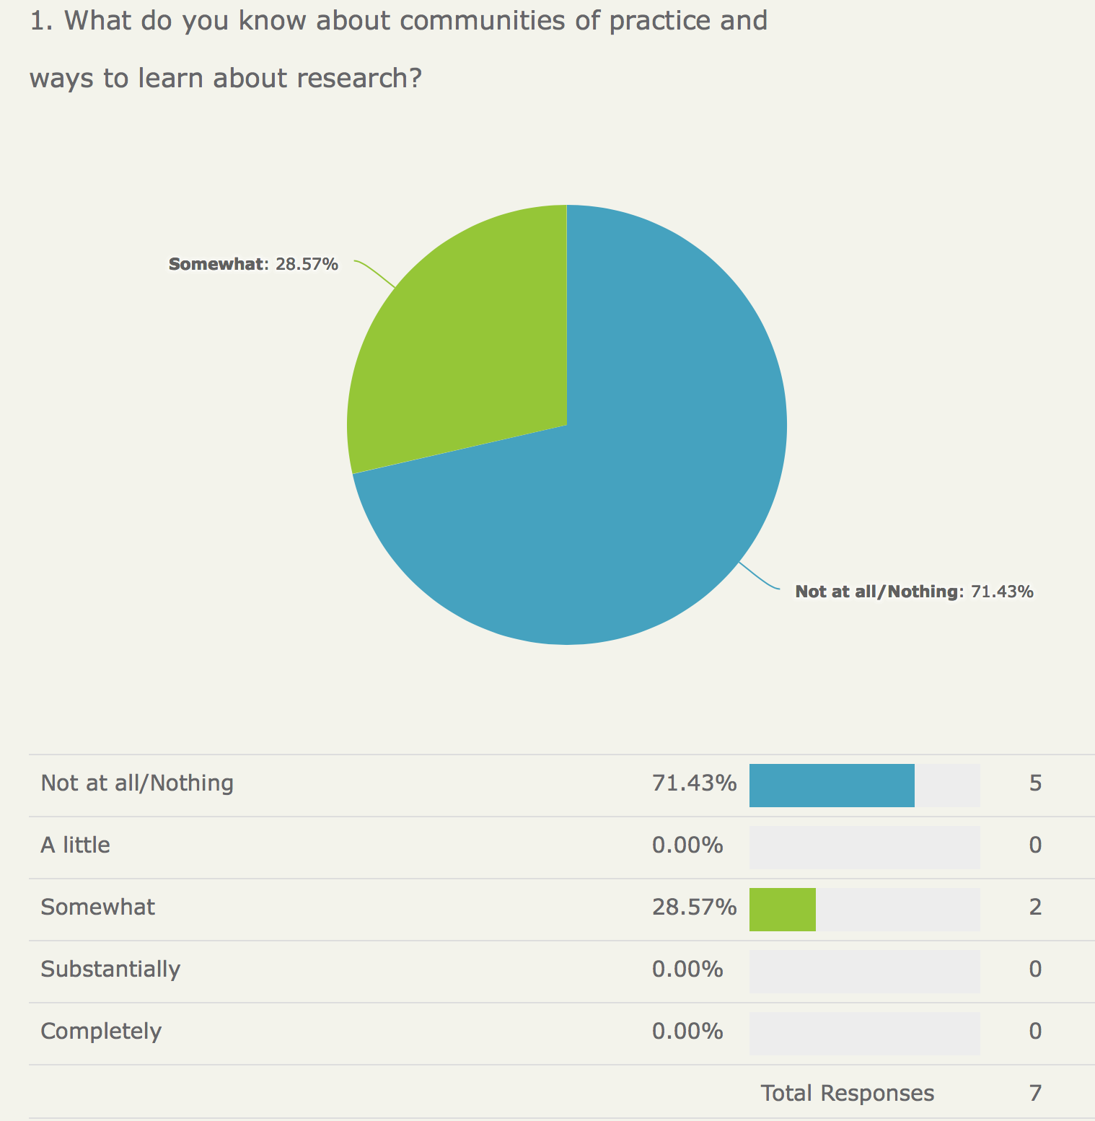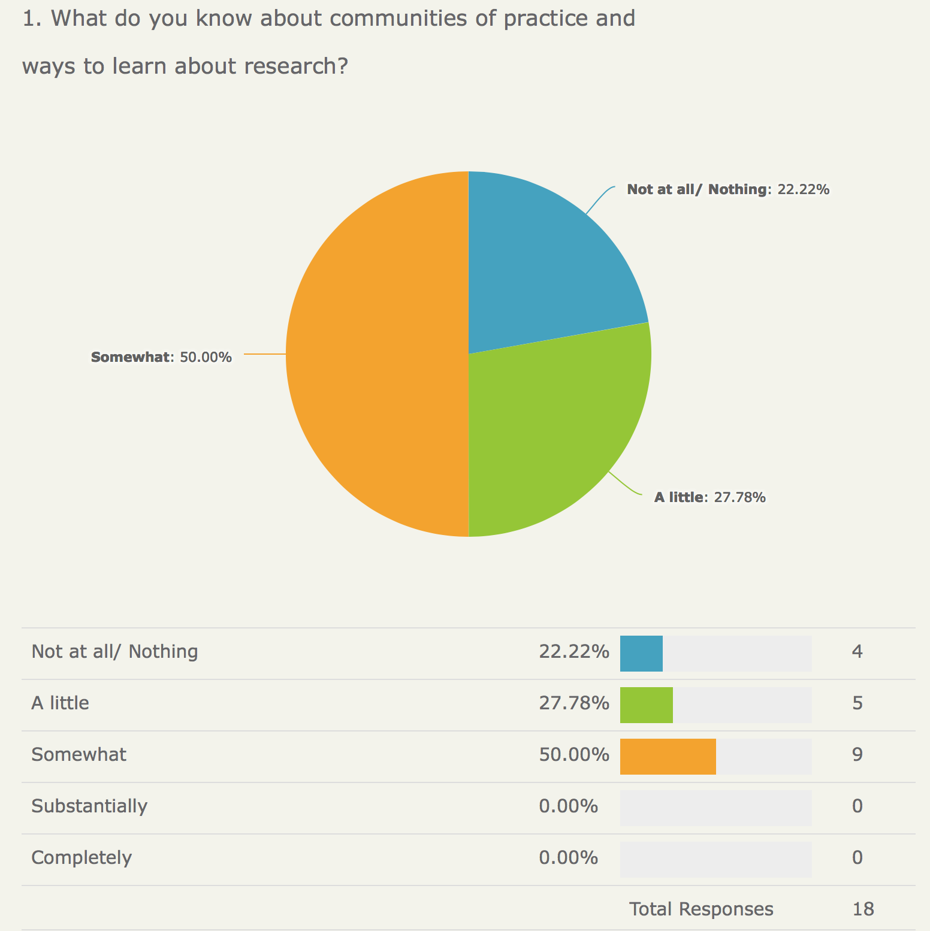

Levels of curiosity about innovation and research have grown
All data suggests there has been an increase in the level of curiosity about innovation and research within the teams since the programme. There is a higher percentage of people having no interest before the programme.

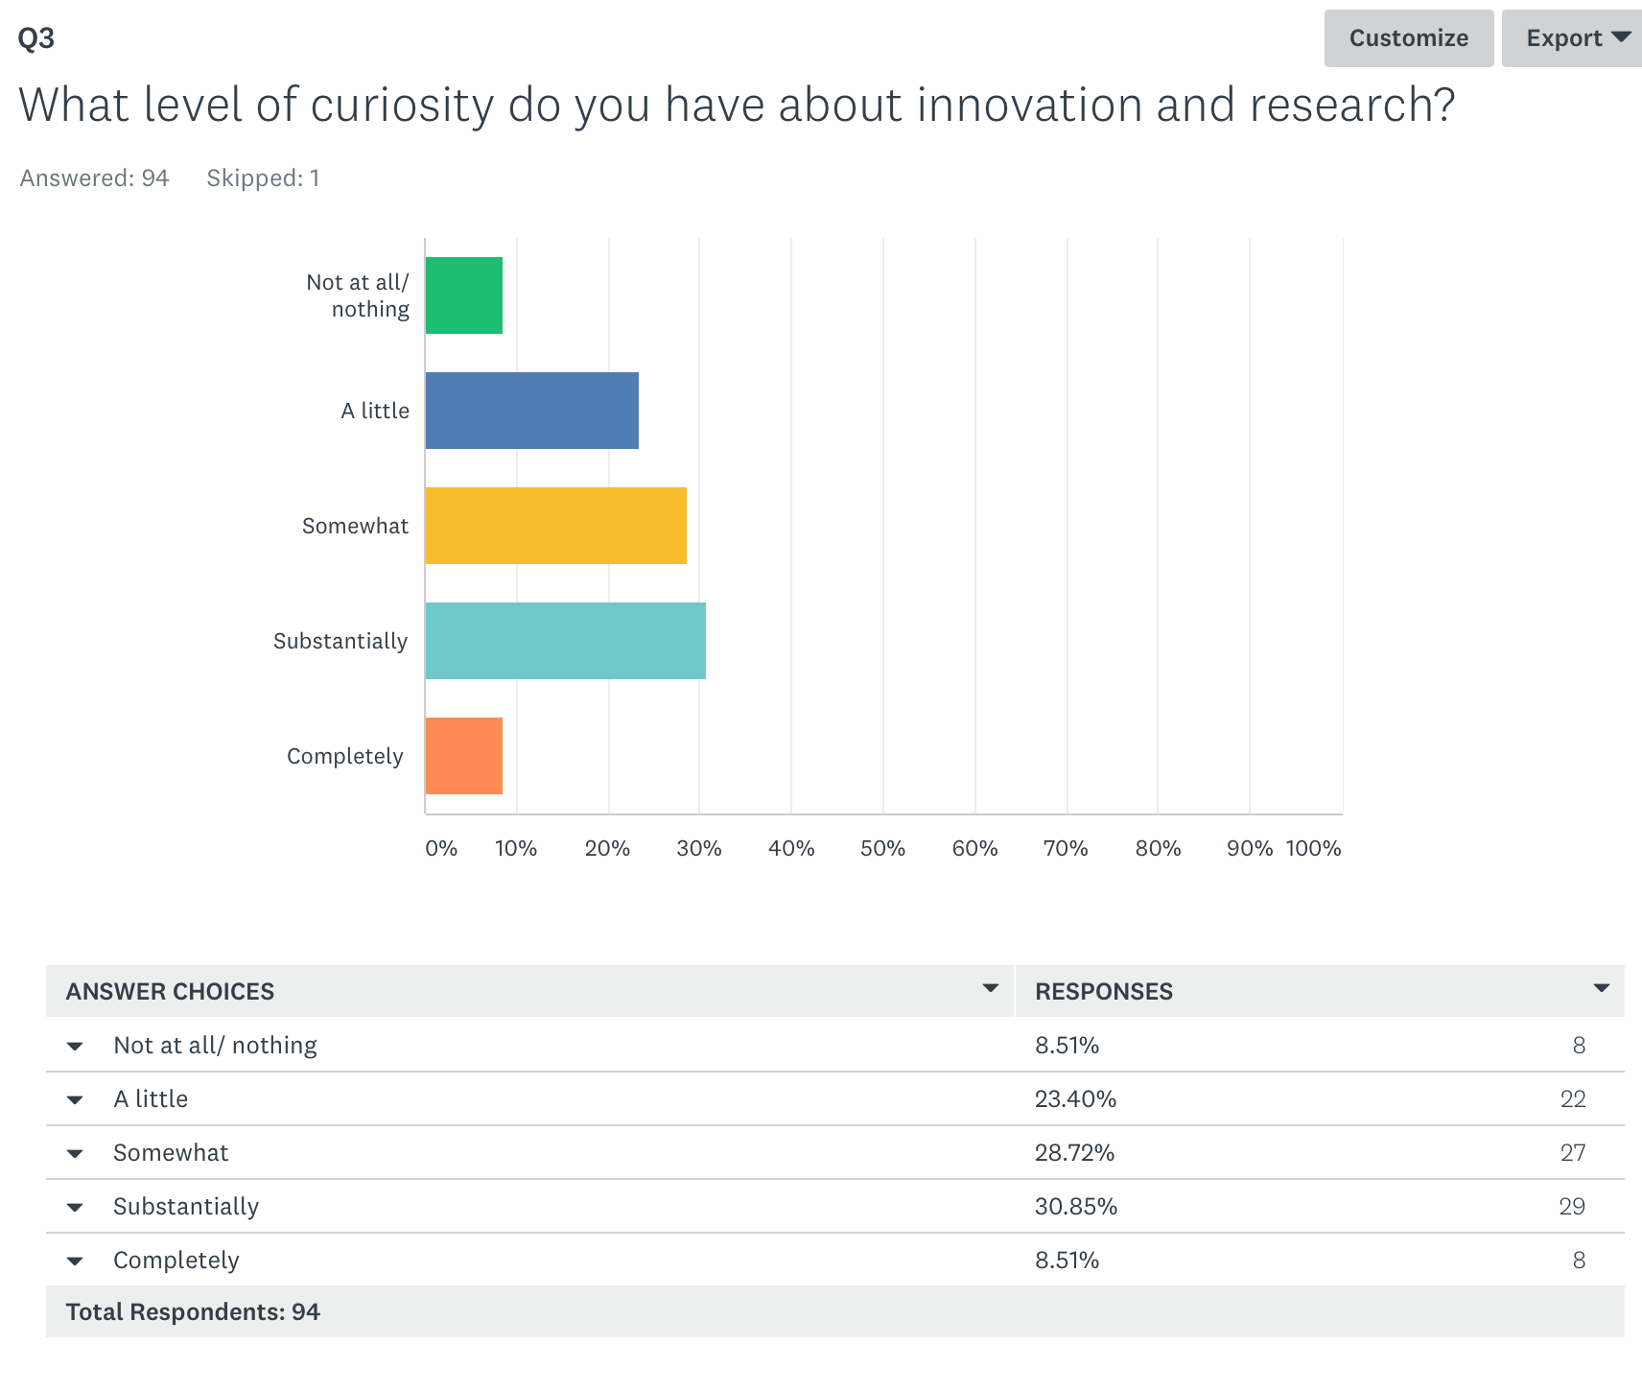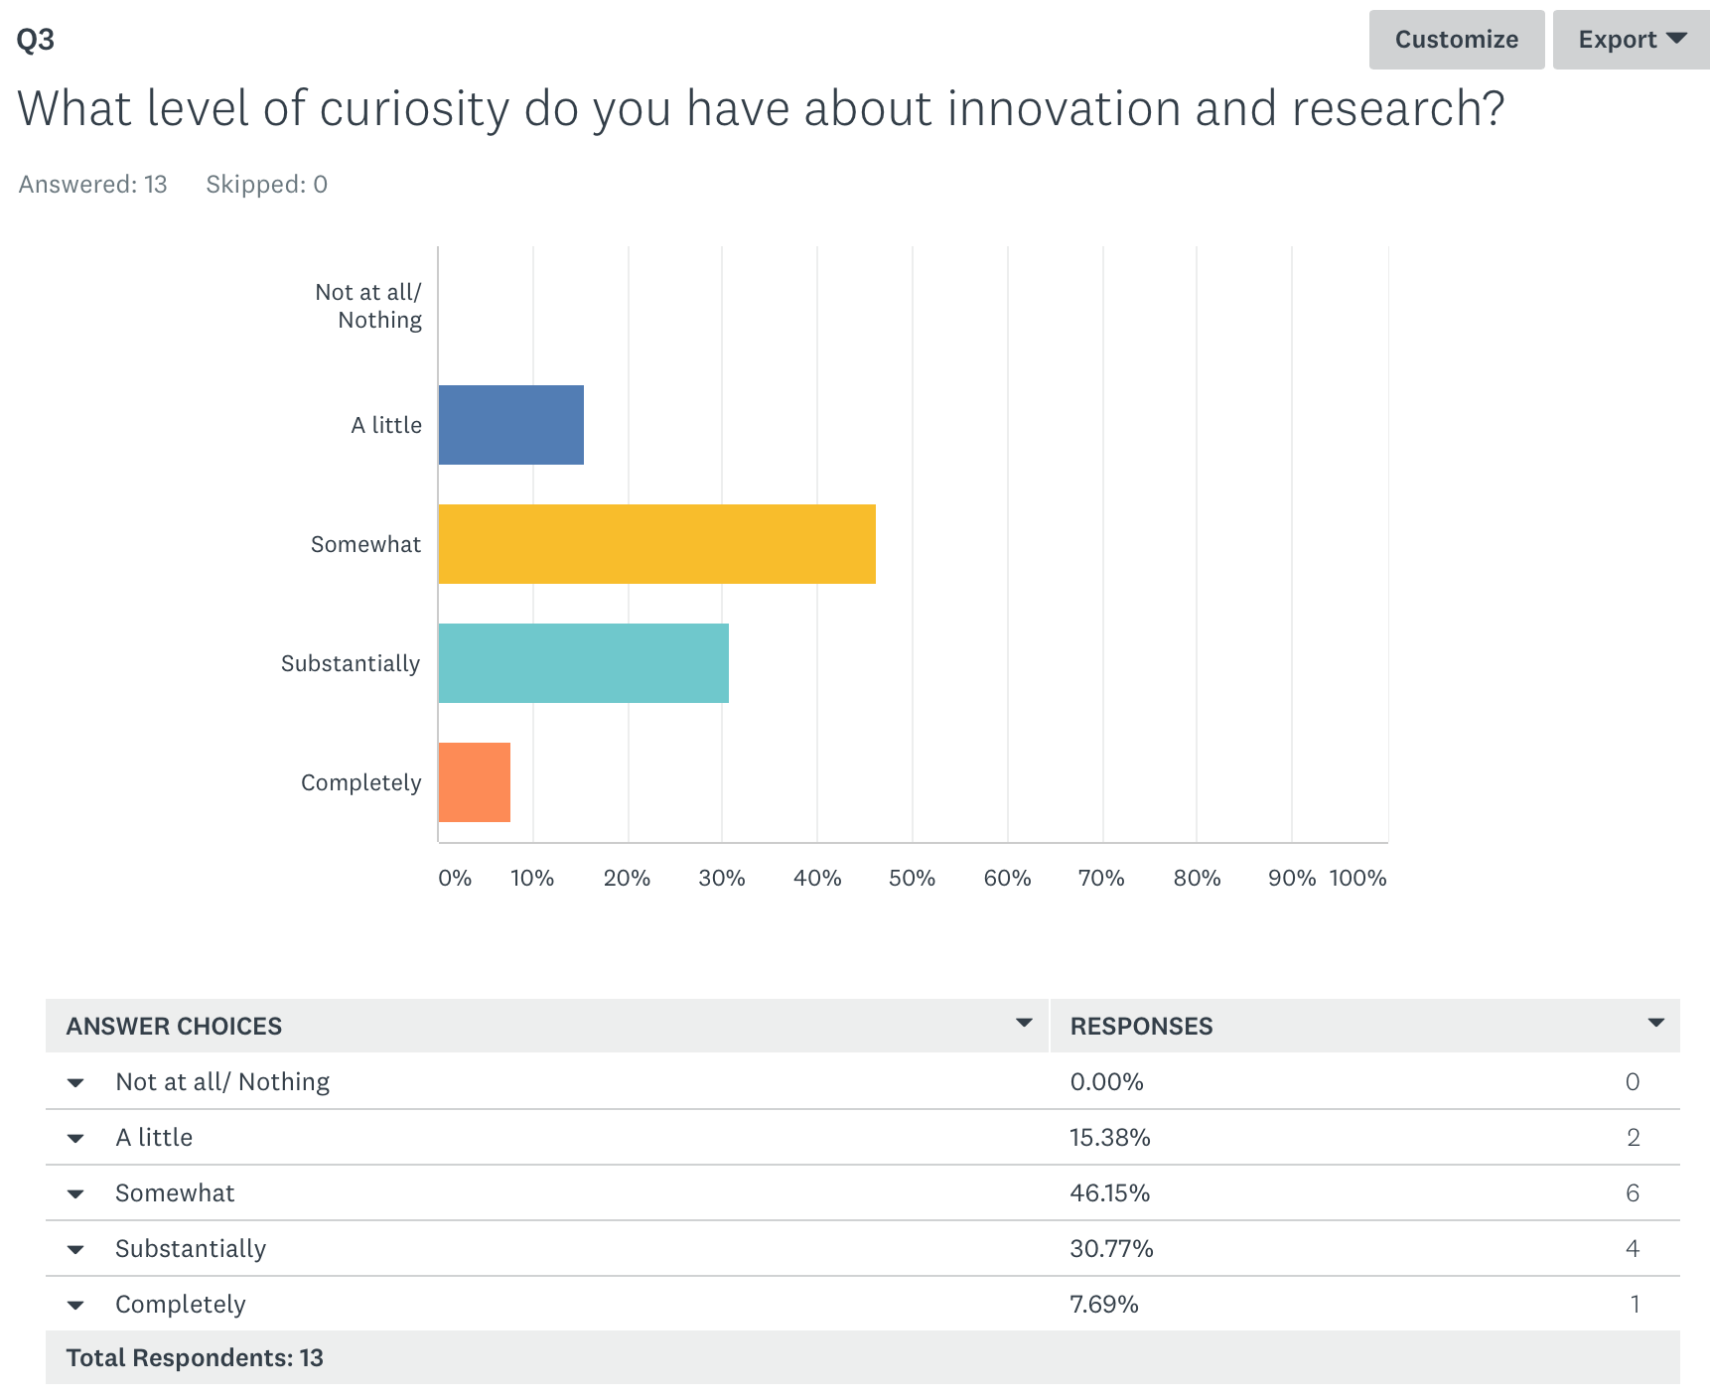

Team members feel line managers are listening more.
Encouragingly, team members are already noticing a change in leadership style from their managers, with a greater level of perceived listening. Before the programme, some team members reported they felt their manager listened a ‘little’ whereas after the programme, 17% feel they are now completely listened to with none reporting only a little.
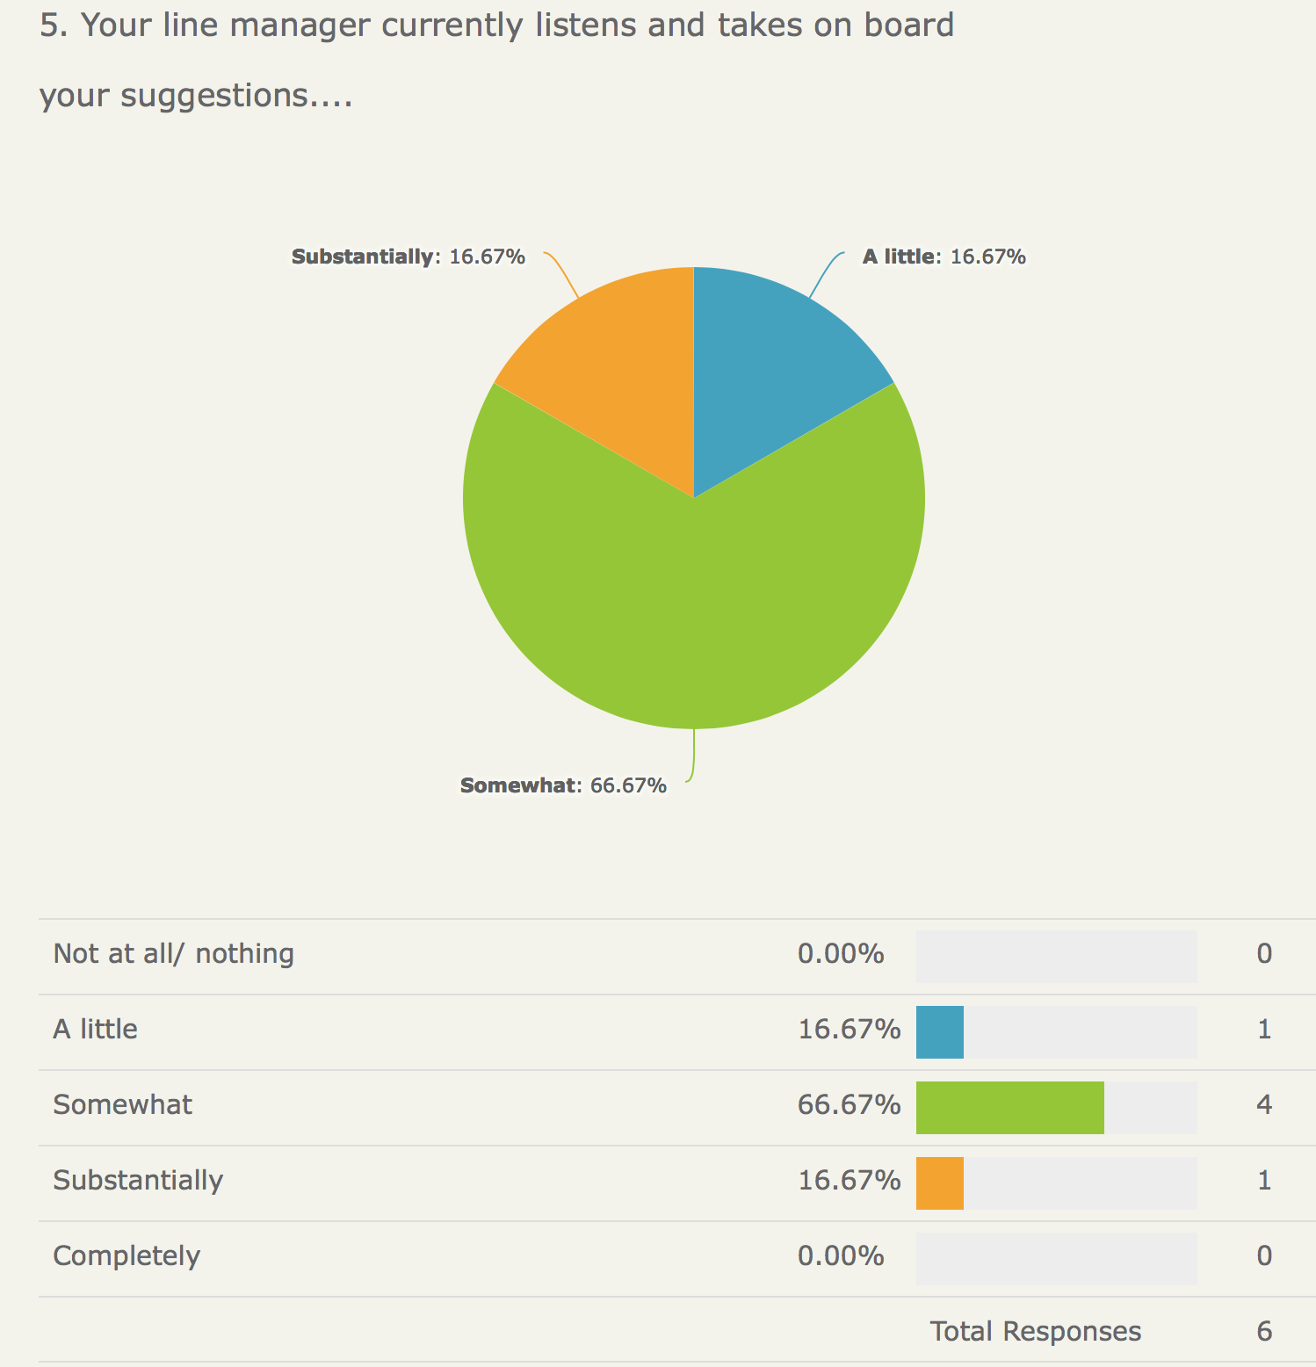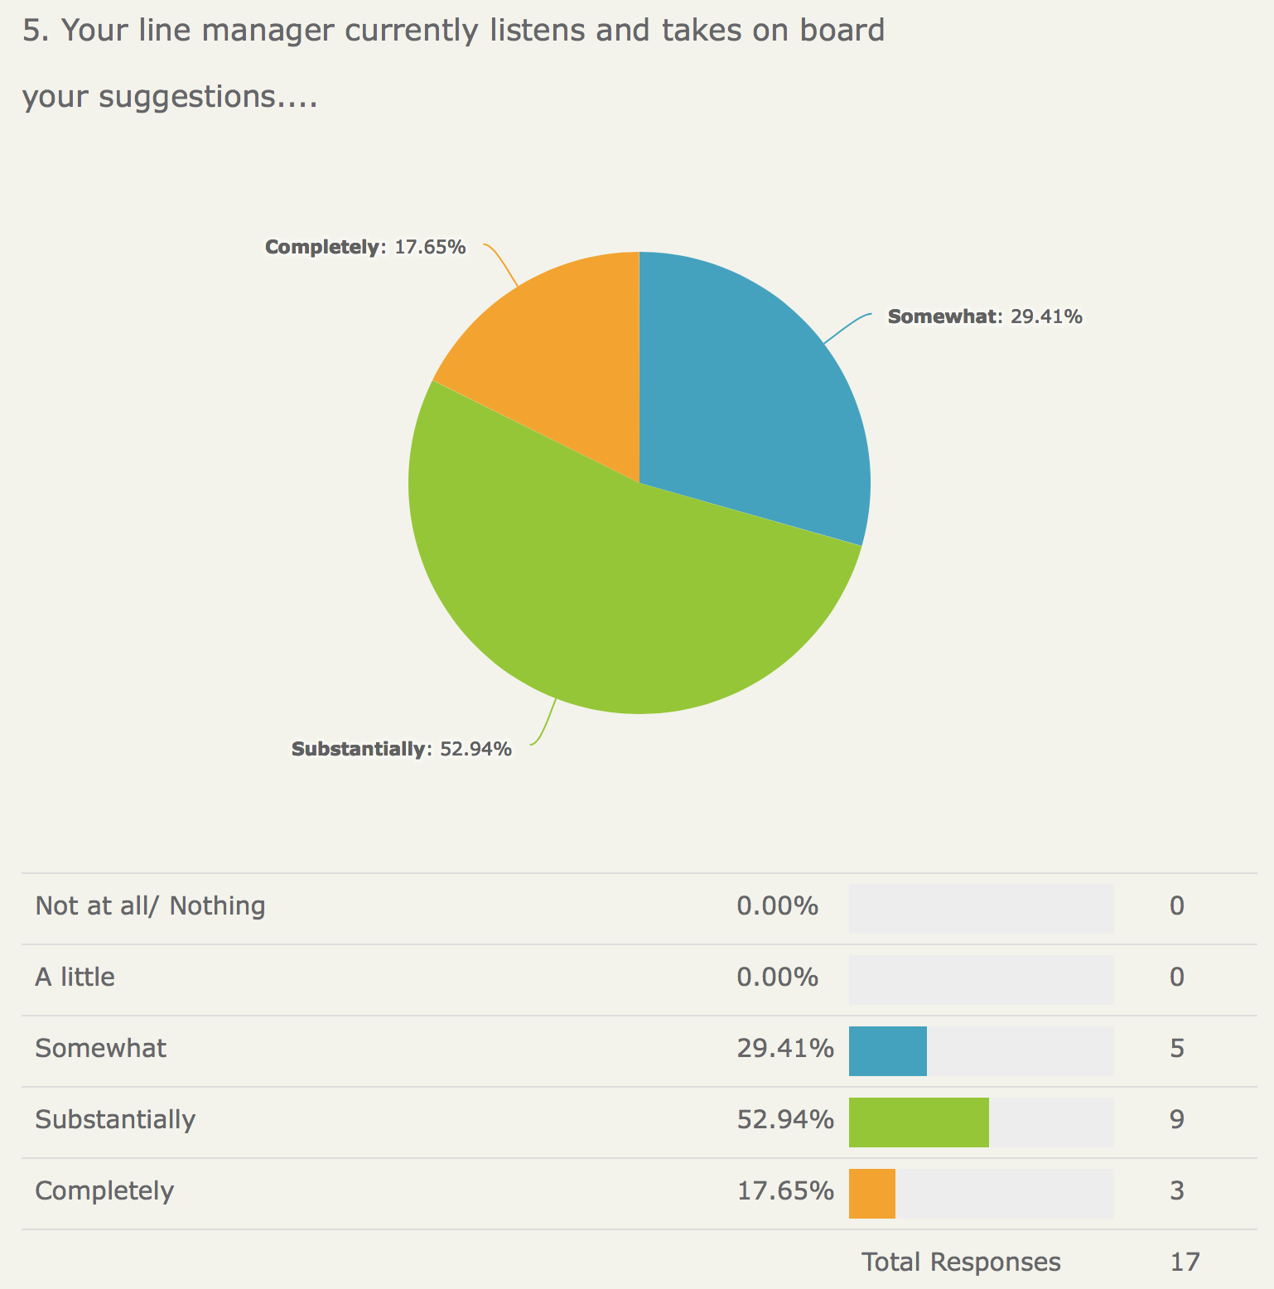

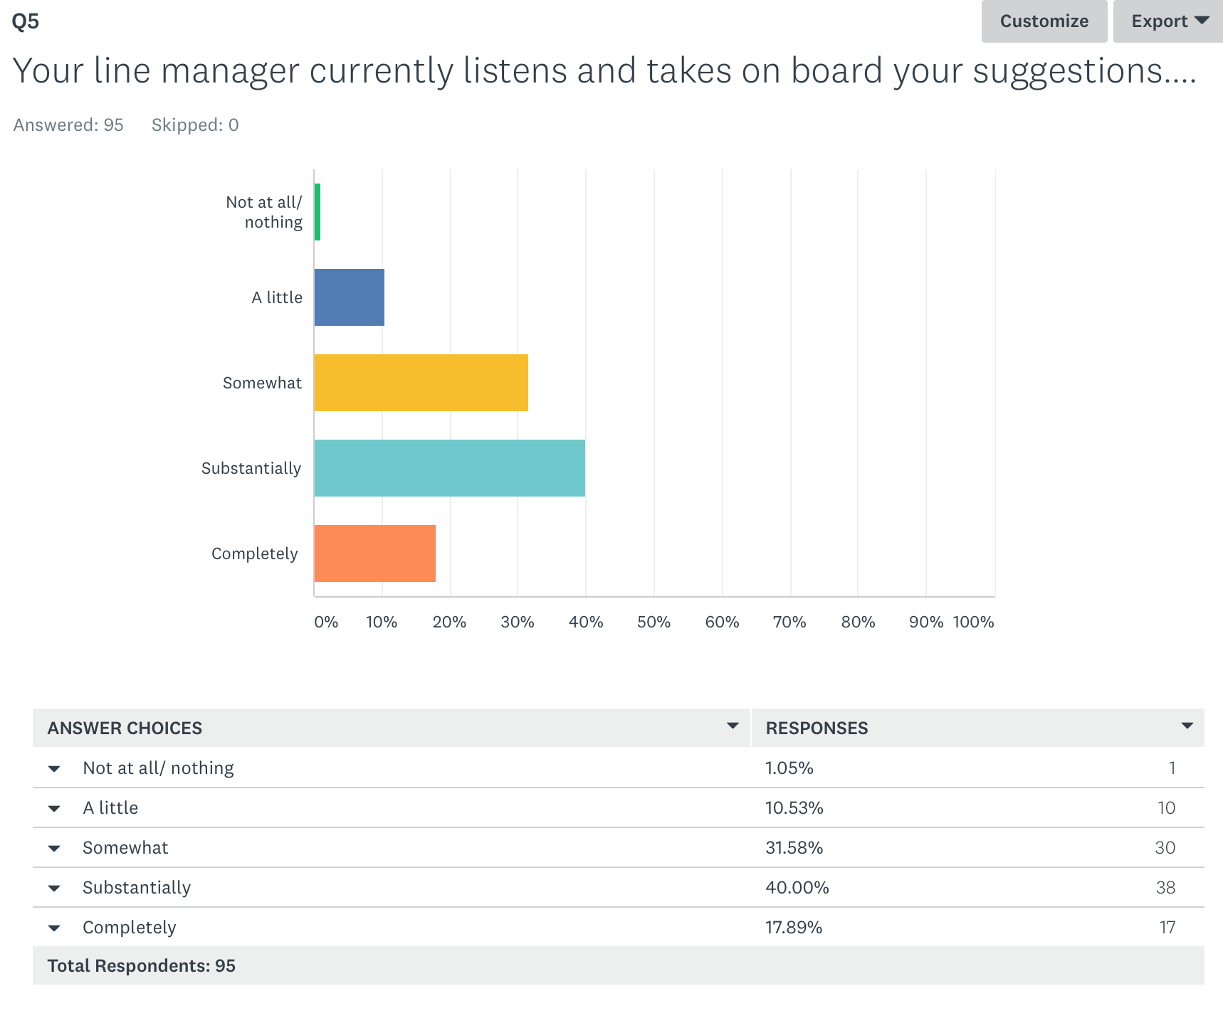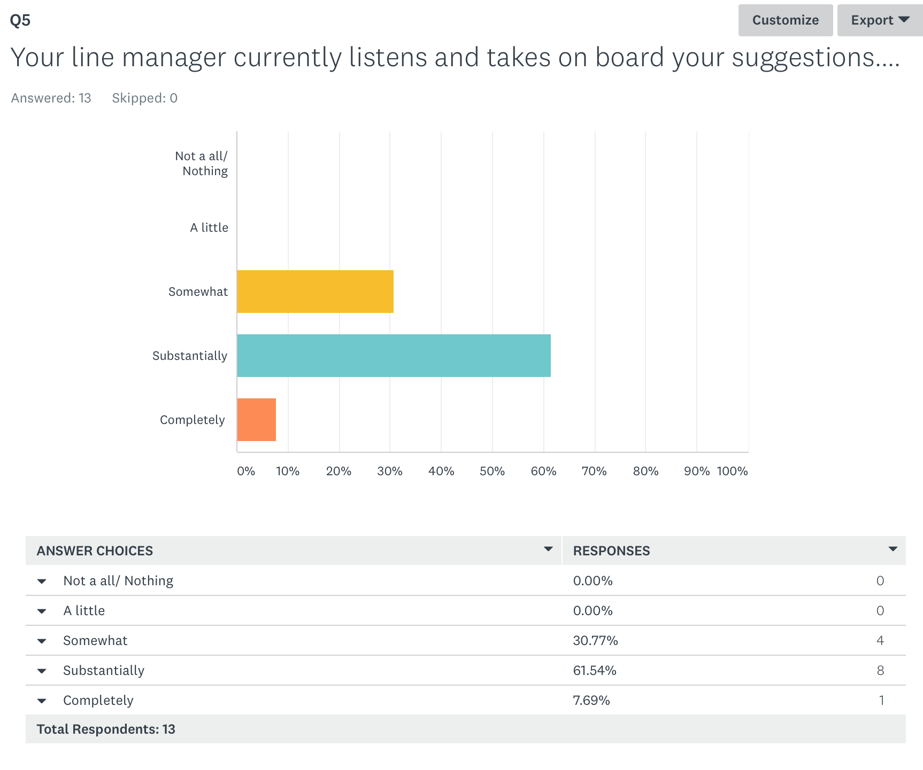

More team members feel their team is able to perform to the best of its ability?
In the pre-programme questionnaire, only 16.6% of team members felt their teams performed to the best of their ability, whereas after the programme, 61.1% felt their team was able to do so.
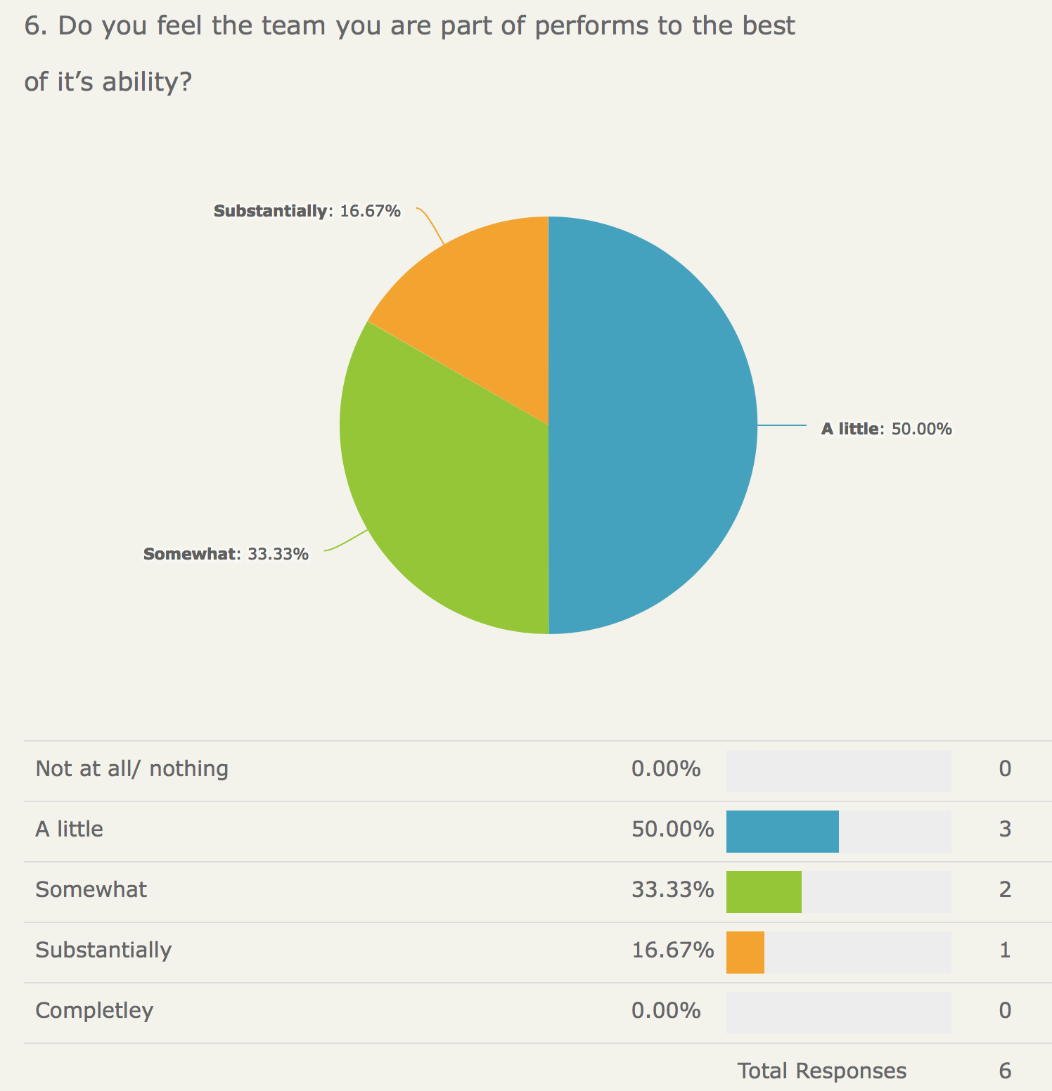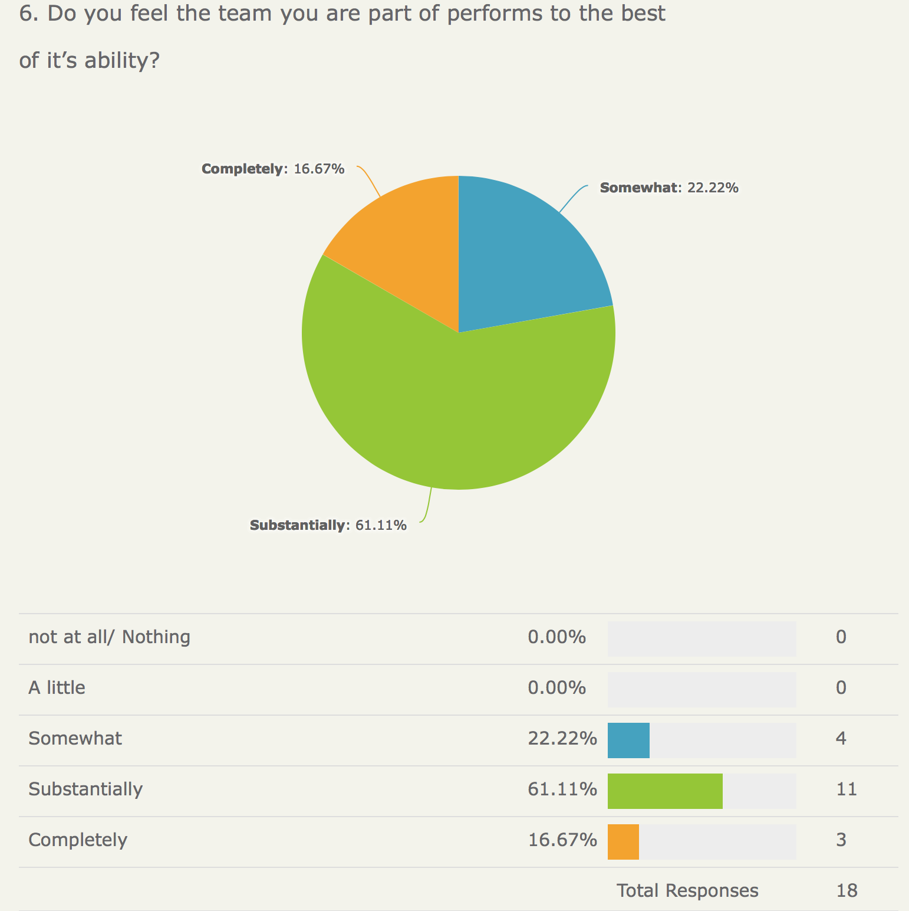

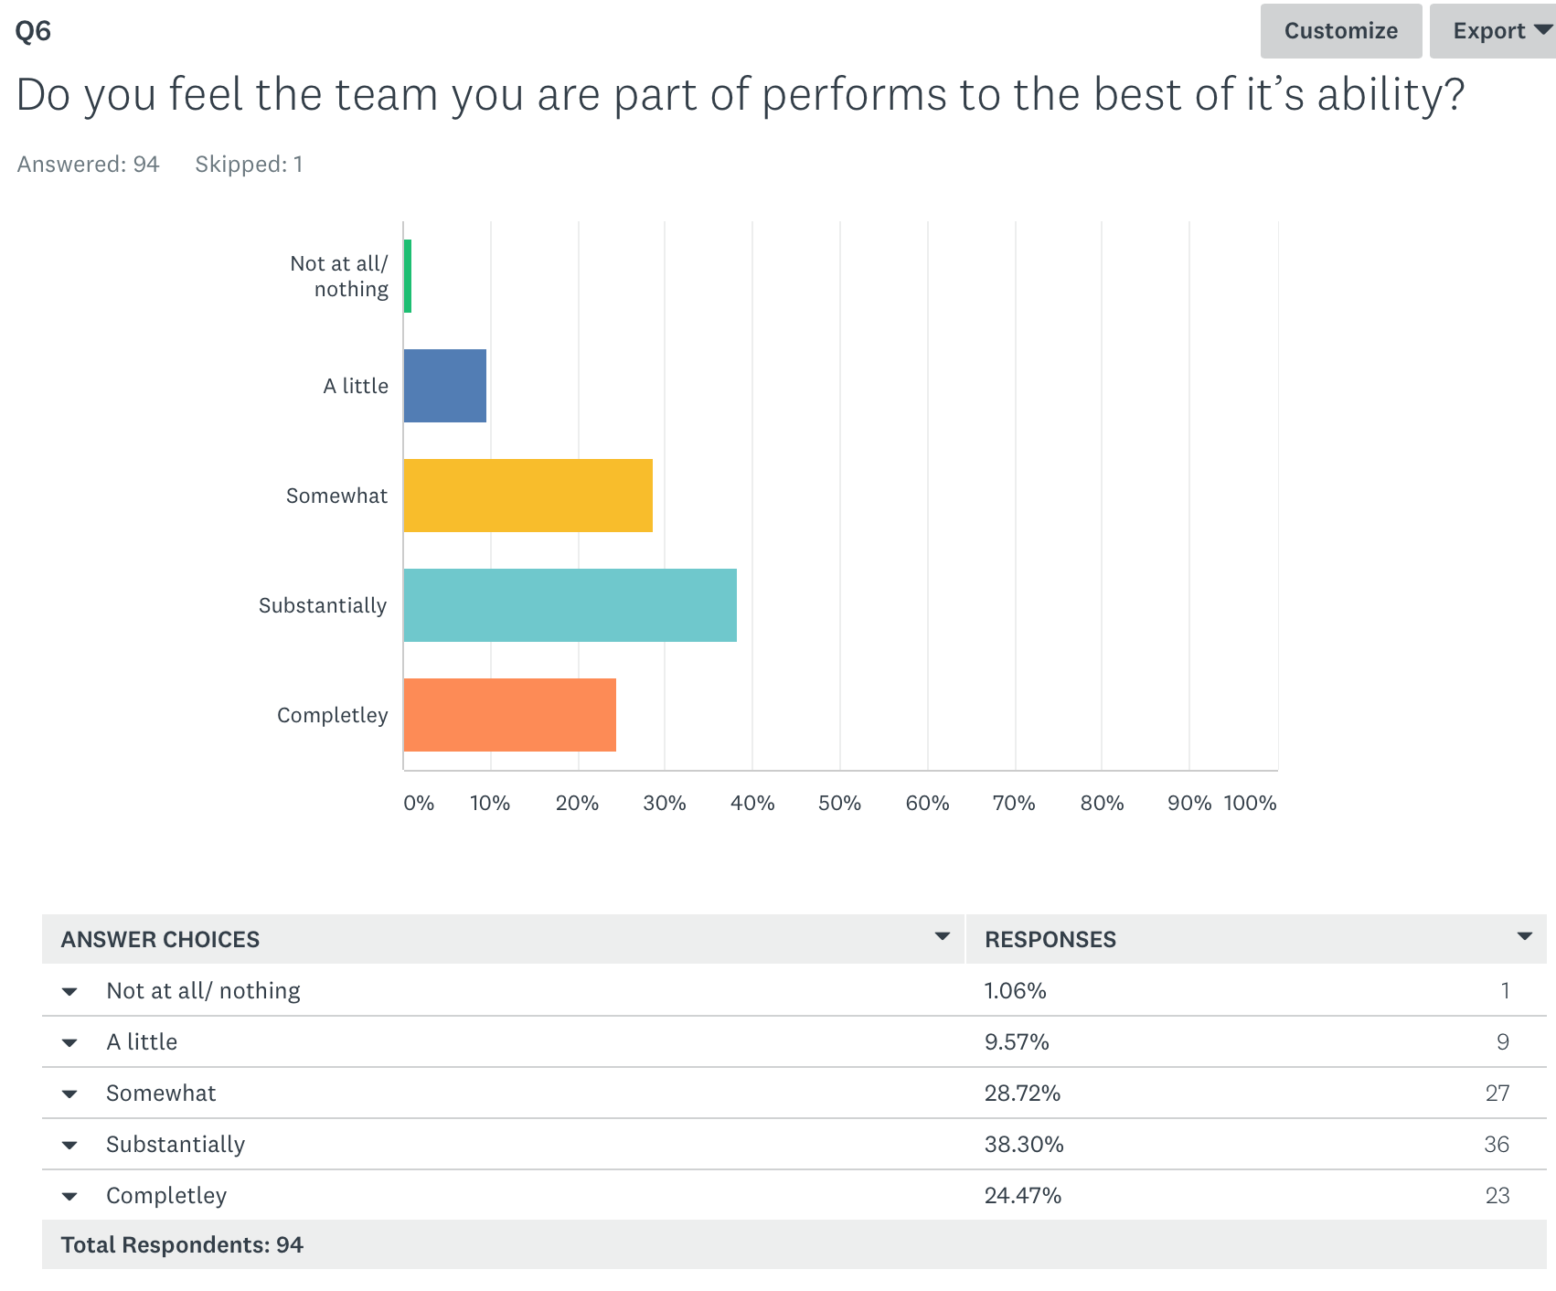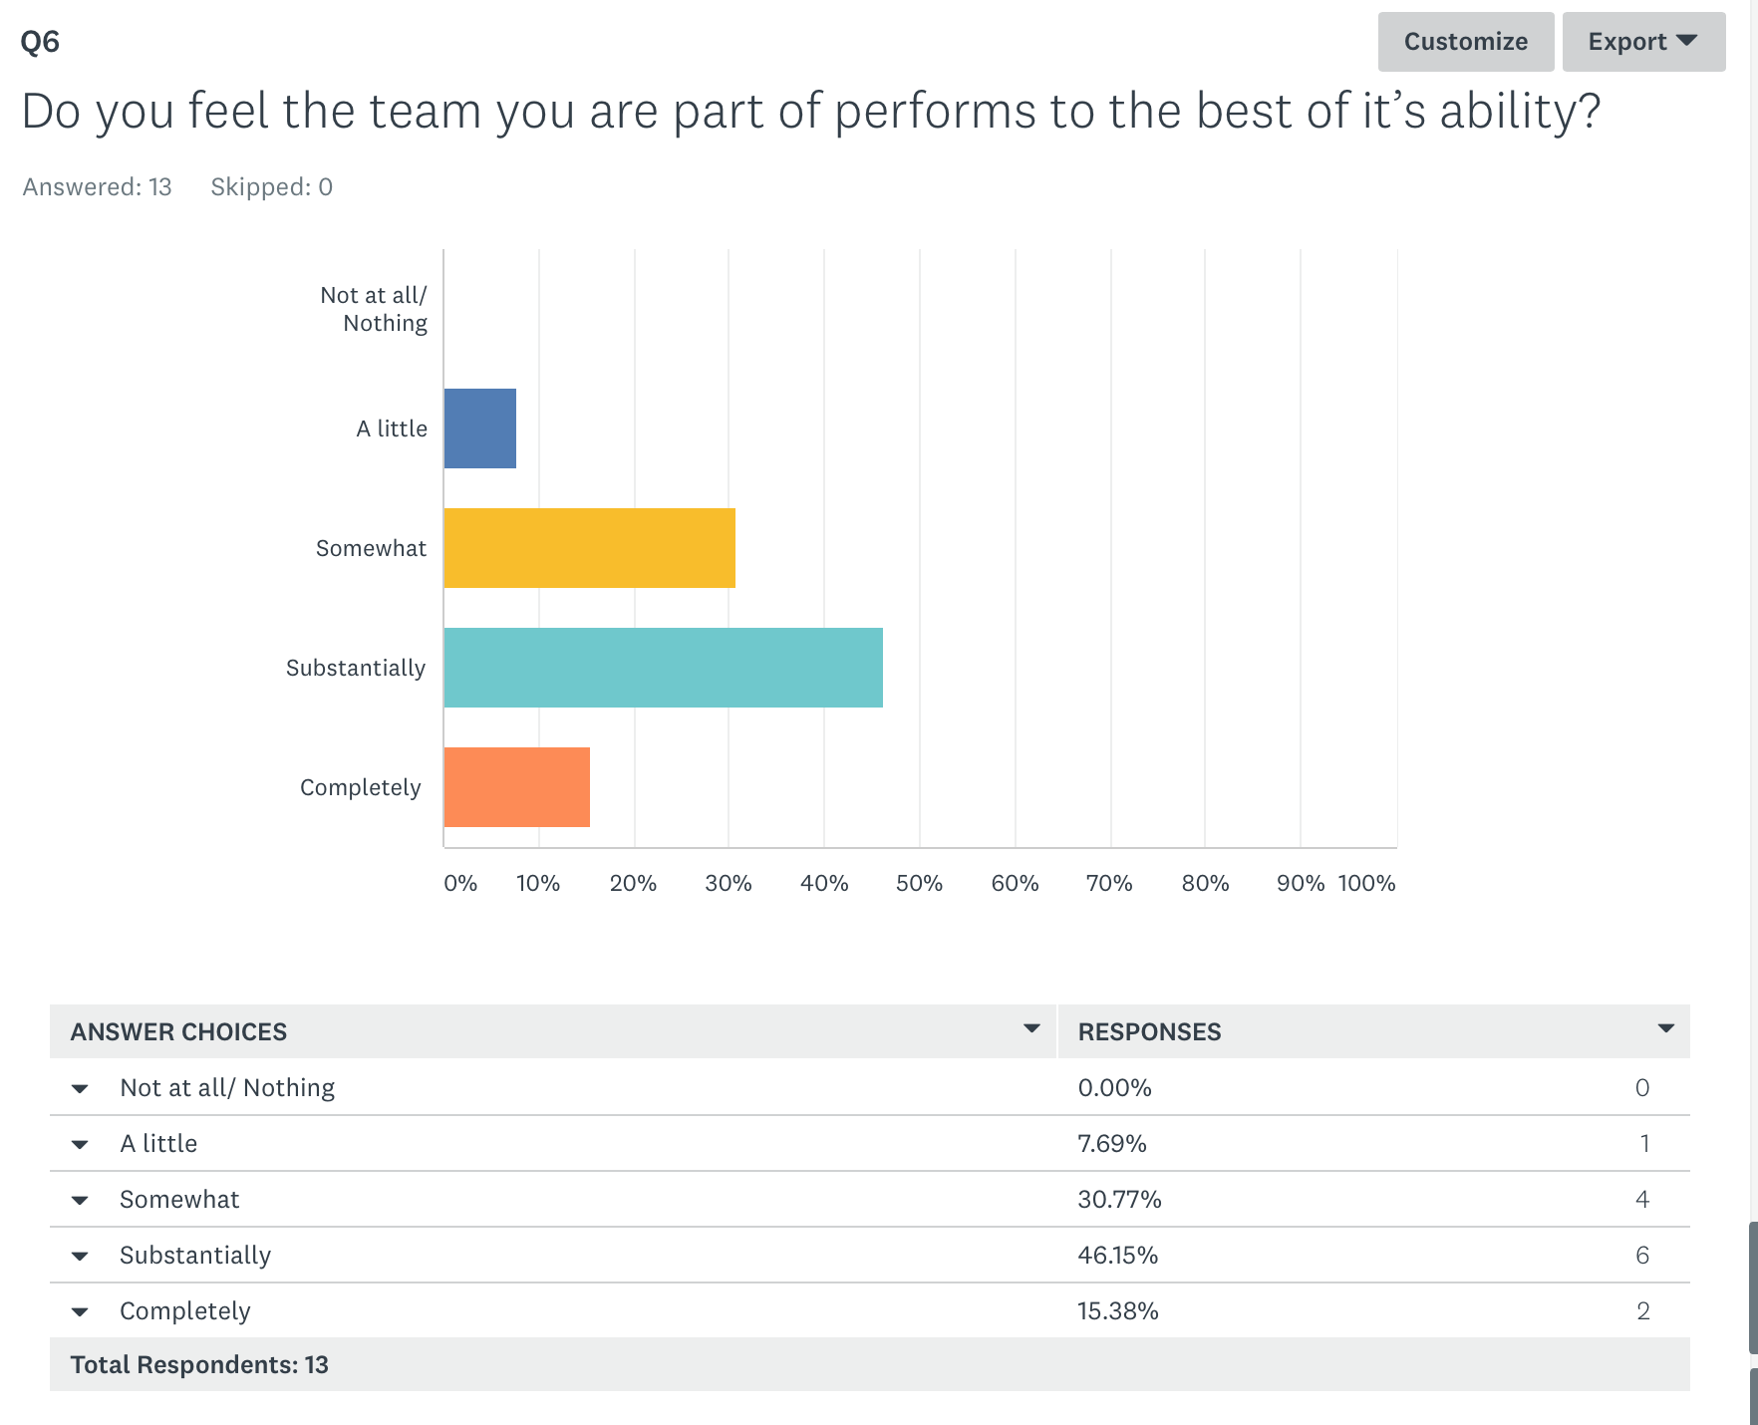

Evaluation themes

Post programme outcomes for participants

Increased confidence
All participants interviewed reported how much confidence they had gained from attending the programme. For one participant this was a renewed sense of her capability to do her job. She said, “it’s reminded me that I can do it!” For another there was a sense of being re-motivated. She described the arrival of the letter that participants were asked to write to themselves:
“it reminded me of how energising it was (the programme) and my commitment to keep going.”

Developing the use of communication and social media to reach a wider audience
Interestingly, whilst few of the participants identified developing their social media skills as a reason for going on the course, all of those interviewed acknowledged how much benefit they had gained from understanding how to use social media such as twitter and What’s App to stay in touch, and to be able to use it as a vehicle to promote their services and activities. One specific outcome which Paul Spencer reported is that as a result of the programme, he is developing a ‘creative reflection’ process for students at the Student Hub Centre. This will be launched in September 2018 and from this, he hopes that a portfolio of creative pieces will be developed.

Greater leadership capability
The participants reported developing their leadership capability through a greater self-awareness and developing creative and innovative ways of working with others and engaging people. For one participant, this was demonstrated in how they now felt confident to approach a wider and more senior audience to suggest ideas. For another participant, this was demonstrated in developing a department vision which wasn’t there before the programme.

Enhanced understanding of research and capacity to use this within their service
For some participants, they reported that research hadn’t really been on their agenda before and now they felt they understood how it could support what they do and help them to disseminate knowledge and for many, they felt more committed to the role that research can play in the future. Sarah Reynolds talked about how she was now in discussion with the research department to look at them doing CPD with her team, to identify ways that the two departments can collaborate and to link with a health and well being survey that is coming up.

Development of peer network through face to face and virtual media
The experiential nature of the programme gave participants a chance to get to know each other and to talk and share experience and ideas in what one participant described as a ‘safe learning environment.’ The participants interviewed recognised that moving people out of their comfort zone from the start, with a mystery bus ride to the overnight residential helped them to bond with their colleagues and one participant reported how she felt “more invested in the programme and my colleagues” as a result.
All of the participants used the Whats App group which was set up for them, and it is still very active now. Participants use it as a safe space to share ideas, doubts and questions and to offer support to each other.
Participants also reported using twitter as a way of connecting and communicating with a wider audience. Paul Spencer recognised that he is now using twitter and never had before and has started conversations all over the world as a result.

Strategies to take teams or service forward
Many participants reported that they had a much clearer direction and strategy of how to lead their team going forward. Whilst one talked about having a department vision for the first time, another described how they felt more confident in their leadership because they had developed a strategy to go forward. Below is an extract from a poem that Paul Spencer wrote and read out at the final day to explain his learning and action plan/strategy to move his service forward. This poem has since also been recited at a research and innovation conference in May 2018:
This is a plan of action
Enable research, overcome distraction
Four simple lines in complex times
Focusing, inspiring minds;

Educate,
Collaborate,
Initiate,
Disseminate.

(Written by Paul Spencer – Macmillan Palliative Care Clinical Nurse Specialist.)

For the full poem, see appendix three.

Programme impact on team perspectives and behaviour
Whist there are clear indicators to a development of knowledge and understanding of research and innovation for both participants and the teams they lead, it appears it is too early to understand how much behavioural change there is within the teams. The questions posed to teams regarding their activity in research and their use of library for example, do not demonstrate a clear change either way. (see appendix four for data and graphs) However, reports from participants suggest that steps are being taken which will support this.

Leadership behaviour demonstrates greater listening which may already be impacting on improvements in team performance
Teams report that they feel more listened to, and that their teams can perform ‘substantially’ more to the best of their ability. This may be due to a change in leadership approach of the participants, which the teams are already noticing and valuing.

Predicted increase in research activity in the future
For example, Paul Spencer is going to incorporate reflective practice more into the next intake of Students from September 2018 in the Student Hub, and Sarah Reynolds has set up a CPD day with her team and the research department so evidence of growth in this area may be seen more clearly six to twelve months hence.

What participants valued about the programme
Participants valued many aspects of the programme as highlighted below:

Innovative approach

Residential element
Those interviewed commented that the start of the programme with a residential element had a positive impact on their experience. One participant described how she had felt out of her comfort zone because they were not told where they were going, but this had helped her to begin the programme with a curious and open mindset. Others felt that this had also enabled them to quickly bond with their colleagues and to create a safe learning environment.

Use of creative media
Participants seem to enjoy learning experientially through creative media. Sarah Reynolds commented that the programme was “varied, memorable and different.” She said there were times when she wasn’t sure where the creative approach was going, but as there was always a choice, it was easy to stay involved. Another participant commented:
“I really enjoyed the mixture of experiential/playful training with the more didactic training. I was also struck by how well looked after/cared for I felt and how this brought out my ‘better side’; this (to care for the person) is an attitude that I have now adopted with my colleagues and I noticed it brings out the best in them too!”

Opportunity to network with other professionals
Participants have valued the support network they have developed with each other, and the opportunity to learn from others. The final day was impactful according to Elaine Fillingham, with the opportunity to hear how others intended to use their learning through their action plans,
All participants used ‘What’s App’ as a medium to stay in touch through the programme and beyond it’s conclusion. At the time of the interviews, two months on from the end of the programme, participants are still contacting each other on ‘Whats App’ to share ideas, ask questions and seek and offer support.

Personal reflection
Participants valued time and space to think and to reflect. For Elaine, the residential was the start of this programme when she realised:
“the world kept turning when I was away for two days and I need to make more time to look after myself.”

What got in the way of the participants learning effectively
The evaluation has shown up very little that participants felt needed improving or got in the
way. Interviewees were asked ‘what were you disappointed about or felt was difficult?’ The response from everyone interviewed was that they wouldn’t change anything. The challenges they identified were around managing their own time commitments. For one participant interviewed, the creative element had at moments felt a bit uncomfortable, but she reported valuing being moved out of her comfort zone.
Comments on the online survey are generally very positive too.
For one participant, there was a danger that a great deal of R&I knowledge was assumed. And for this participant, this wasn’t already there, so found it difficult to understand R&I concepts that were being pitched without an in-depth foundation beforehand.
There was also a minority view that it wasn’t clear how the leadership and research elements linked to the creative approach so perhaps more work making those links explicit would be helpful.

Future programme improvements
The evaluation has not found any significant improvements needed. Participants valued the innovative approach and report gaining a significant amount from attendance. Minor amendments could help to address the two points raised in the previous section:
- Consider the audience and don’t assume levels of knowledge about R&I
- Ensure links between the leadership & research elements and the creative experiential activities can support learning transfer.

Conclusion
Feedback from both participants and their team members suggests that there has been significant value from attendance on this programme. The participants who responded to the post-programme evaluation report a huge value from the course. The innovative and creative approach was appreciated, with one participants commenting that it was very different and for her, that made it the best programme she had ever been on!
For both teams and their managers, there have already been reported improvements in the way the team performs, and greater levels of listening are valued by team members. Knowledge of both R&I and innovation have increased, along with a greater confidence to use research and to know how to both evidence and use research to support service delivery.
As one participant described:
“I think it has really awakened a creative element within me that is beneficial to my leadership skills and clinical practice. It has definitely helped me to ‘think outside of the box’ and consider new, effective and innovative ways of communicating and presenting information”
And another participant commented:
“I have an increased confidence in making things happen and an even greater desire to ensure that Service users and Carers become more involved in research as equal partners.”

Acknowledgements
Thank you to Gillian Southgate who provided insight into the programme and to Leanne Gregory, who organised the collation and administration of the online surveys and contact details for the interviewees. Also, thank you to all of the team members and participants who completed the surveys and to the participants who took time to be interviewed: Paul Spencer, Sarah Reynolds, Elaine Fillingham and Jo Riley.

Appendix One - Overview of the programme

Leadership Development Facilitators' Programme
January 2018
Day 1 -residential
- Coach pick up 9am from Chorlton Street bus station, Manchester
- Jana to give everyone seat number?? (Need clarity on this??) and give out goody bags and Gillian to welcome and introduce self and explain journals
- All facilitators to do quick hello and Jana to lead warm up exercises and coach games

Proposed timings and session leaders: -
9.40 Arrive by coach at The Last Drop Hotel and unload bags and walk to conference facilities
9.45 Coffee and Pastries
10.00 Group warm up
10.15 Course introduction and Culture of R&I
10.45 Reflective diary turbo session
10.50 Making the case for R&I
11.25 Reflective diary turbo session
11.30 Coffee
11.45 Culture of R&I
12.30 Reflective diary turbo session
12.35 Lunch
1.15 Group work - divide into
3 superhero groups
2.00 Reflective diary turbo session and move
2.10 Group work
2.55 Turbo session and move around
3.05 Group work
3.50 Turbo session and close of afternoon session.
4.00 - 6.30 check in and free time
6.30 Pre-dinner look at sculptures from workshop and prize for winner

7.00 Dinner

8.00 After dinner speaker - Professor Alison Chambers, Manchester Metropolitan University

Day 2 -residential
7.30 Optional yoga stretching and meditation
9.00 Group warm up
9.15 Self-assessment discussion and creative writing, "make a super hero story using self-limiting
beliefs"
10.15 Reflective diary turbo session
10.20 Community mapping
11.30 Reflective diary turbo session
11.35 Coffee
11.45 Real life case studies
12.35 Reflective diary turbo session
12.40 Lunch
1.30 Networking and next steps (commitment going forward)
2.30 Reflective diary turbo session
2.35 Bingo books with all the team
3.00 Coffee
3.10 Leadership first aid packs
3.30 Reflections, evaluation and close
4.00 Coach back to Chorlton Street bus station, Manchester

Day 3:- Brockholes Nature Reserve, Preston

9.00 Registration and coffee
9.30 Warm up
9.45 Feedback from challenges, scores, Creativity and context (3 super hero groups)
10.30 Reflective diary turbo session
10.35 How do you influence people?
11.35 reflective diary turbo session
11.40 coffee
11.45 Role play with team looking at how to Influence people
1.00 Reflective diary turbo session
1.05 Lunch
1.45 After lunch warm up
1.55 Components of a research culture and Jo Cooke quiz
2.30 Reflective diary Turbo session
2.35 Expert panel - An opportunity for the super-hero groups to ask some questions
3.35 Reflective diary turbo session
3.40 evaluation and close
4.00 Facilitator review session
Day 4;- Friends meeting house, Manchester

9.00 Registration and Coffee
9.30 Warm up
9.45 Leading with care
10.15 Working in teams
10:45 Reflective diary turbo session
10.50 Coffee
11.00 Rehearsals in small groups
11.30 Prep time for the afternoon
12.30 Lunch
1.15 Afternoon presentations of action plans for everyone completed in superhero groups -
presentations must aim to use creativity and skills learned during course.
3.00 coffee and cake
3.15 Feedback and evaluation/ celebration and certificates
4.00 Close

Appendix Two Participant list
Name | Job Title | Organisation
Carol Howard | Infection Control Nurse Specialist | SRT
Deborah Smith | Ward Manager | MFT
Don Bryant | Service User | Merseycare ft
Elaine Fillingham | Principal Medical Physicist | LTHTR
Helen Wilson | Quality Lead | North West Boroughs Healthcare NHS Foundation Trust
Jacqui Hudson | Radiotherapy Clinical Trials Radiographer | LTHTR
Joanne Riley | Expert Cardiac Physiologist | NW Heart Centre
Julia Noble | Counselling Psychologist | North West Boroughs Healthcare Foundation Trust
Julie Bury | Physiotherapist/Research Fellow | Doncaster Royal Infirmary
Kathryn Stanton | Modern Matron | MFT
Lina Papista | Clinical Psychologist | Tameside& Glossop Psychological Therapies Service
Lisa Martin | Team Leader | North West Borough Healthcare
Lisa Price | Clinical Lead for Resuscitation | Aintree University Hospital
Michael McNamee | Modern Matron | MFT
Michelle Mathers | Acting Team manager | Greater Manchester Mental Health
Paul Spencer | Macmillan Palliative Care Nurse Specialist | MFT
Rebecca Bradley | Team Co-ordinator
Safiah Casooji | Advanced Orthoptist | Lancashire Teaching Hospitals NHS Foundation Trust
Sam McVeigh | Lead Nurse | SRFT
Sarah Reynolds | Team manager of Community Living Skills Mental Health Team | Lancashire Care
Simon Graham | Senior Nurse Practitioner | SHOT
Tamsin Moody
Vicki Conroy | Senior Clinical Research Nurse | MFT
Wendy Moens | Nurse | Aintree University Hospital

Appendix Three. Poem by Paul Spencer, participant as part of final presentation. (published with permission)
This is an Action Plan

This is a plan of action
Enable research, overcome distraction
Four simple lines in complex times
Focusing, inspiring minds;

Educate,
Collaborate,
Initiate,
Disseminate.

One: Educate

Team Time, team talk,
Reflect and learn then walk the walk.
Embed research and innovation in our agenda,
Highlight in appraisals to help us remember.
Engrain it in our philosophy,
Discuss it over a cup of tea.
Formalise with qualifications
And sustain for the next generation.
Creative reflection.

Two: Collaborate

Exchange, develop, enhance
Give every novice and expert the chance
To dance to the sound of their own drum
But beat together.
Share and listen.
Shake off isolation, alienation, frustration.
Look around, over and underground
For resounding relationships, many already exist;
Universities, different sectors,
Researchers and policy makers,
A diverse spectrum of professional movers and shakers.
All can become Champions.

Three: Initiate

Start small then grow
Audit we already know.
Next steps sow the seed
Identify research that practice needs.
Soon, grants will be accepted
Published papers expected,
Our team represented at the finest conference centres.
Time to blossom

Four: Disseminate

If we don’t share we contract,
Form cracks, break away, subtract.
So make a concerted effort to give back.
Consider the social impact of our actions.
Mobilise the Twittersphere,
Form Facebook groups, make people hear.
What’s that app again? Research blogs, Mum’s Net.
Time to think outside the box.

Engage our friends in Communication,
Spread the work across the organisation.
Palliative Priorities is our newsletter,
Research and innovation can make it better.
And let’s not forget our service users.
Patients that are out and in,
Don’t commit a deadly sin and ignore their voice;
Give choice.
Involvement from start, middle to end;
Befriend.

This is a plan of action
Lyrically composed for your satisfaction.

Educate,
Collaborate,
Initiate,
Disseminate.

Four simple steps to generate debate;
Enable change.

This is an action plan,
And here is where it all began.

Paul Spencer – Macmillan Palliative Care Clinical Nurse Specialist

Appendix Four. Team evaluation results not shown in main report.
- To what extent do you participate in research?
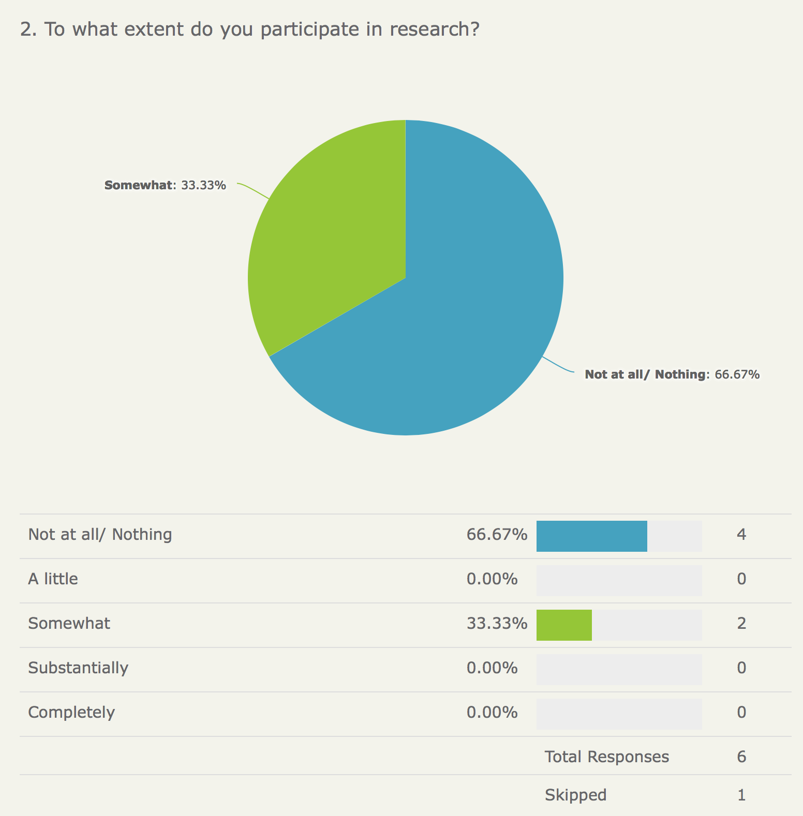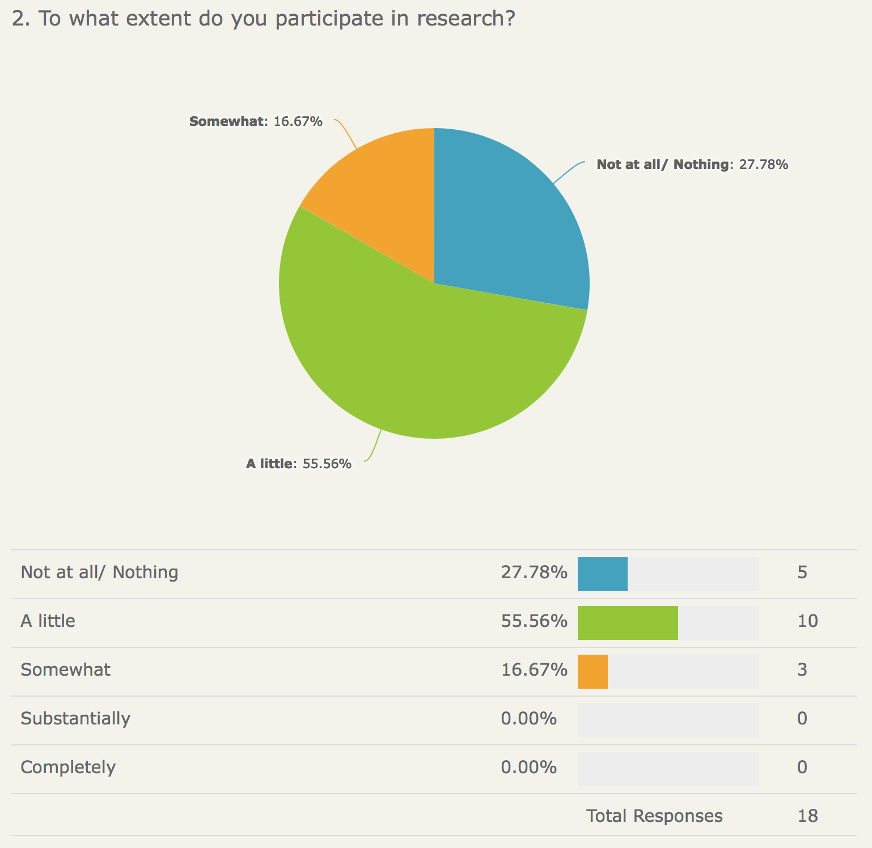
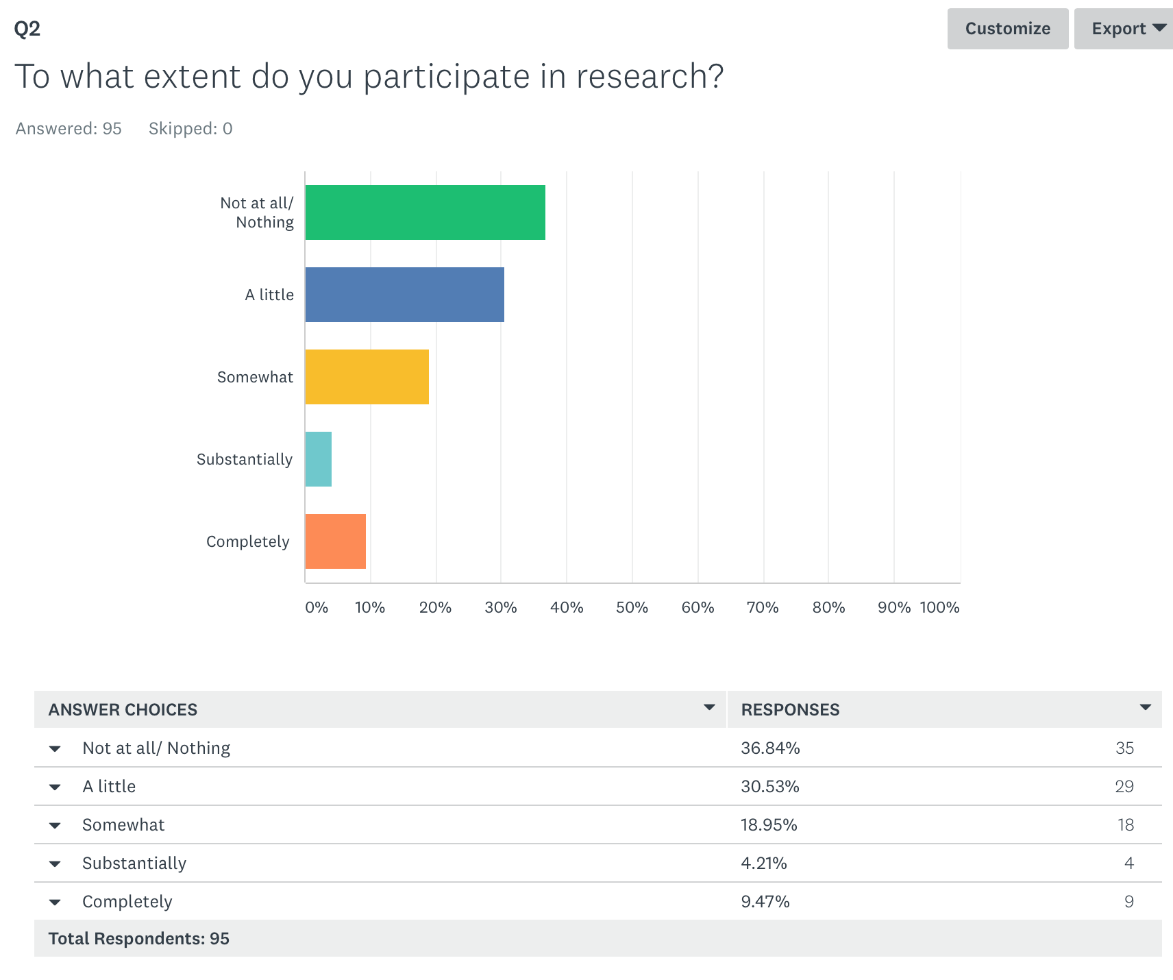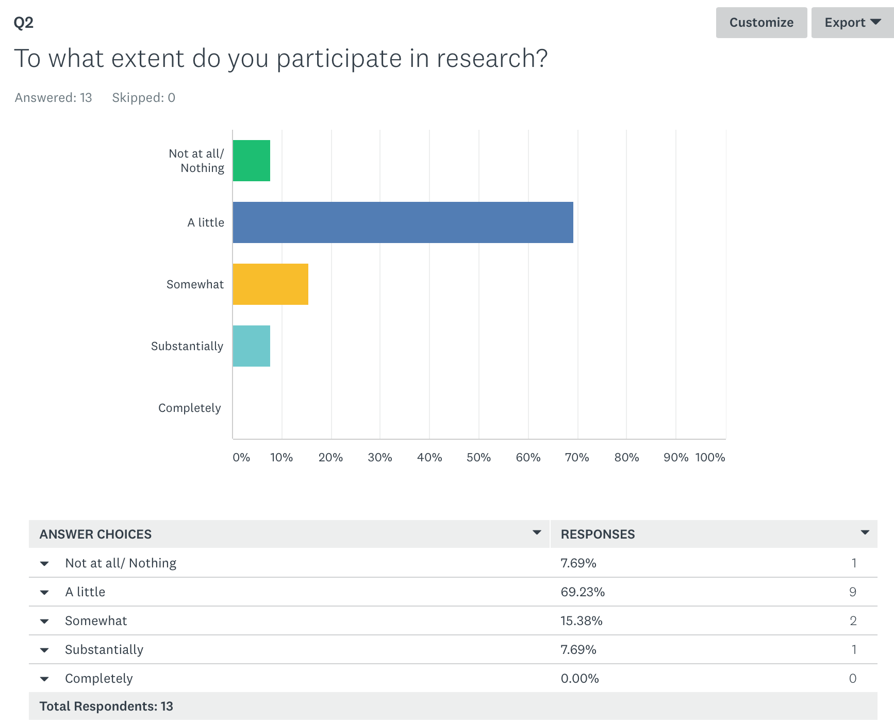
- How often do you use the library or go online to read about clinical practice and the latest research in your area of speciality?

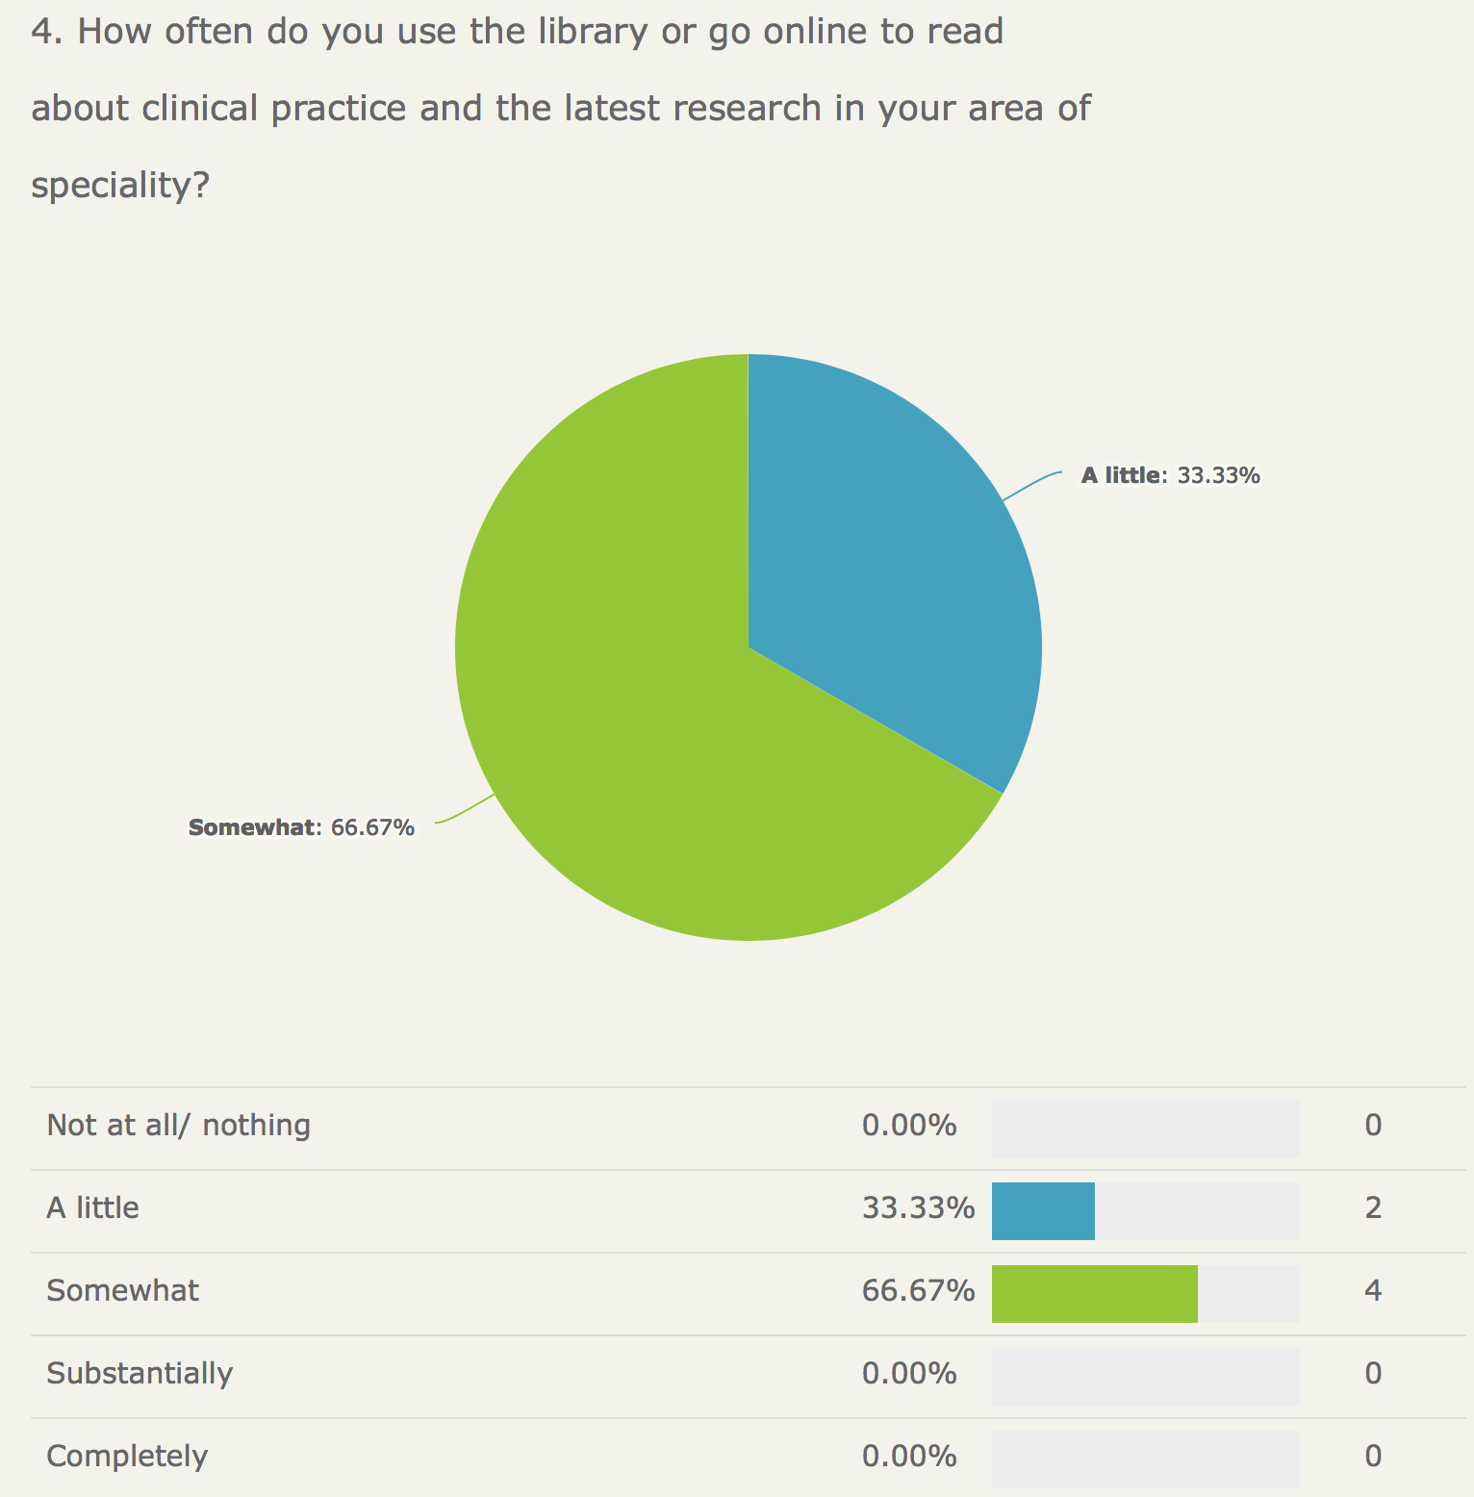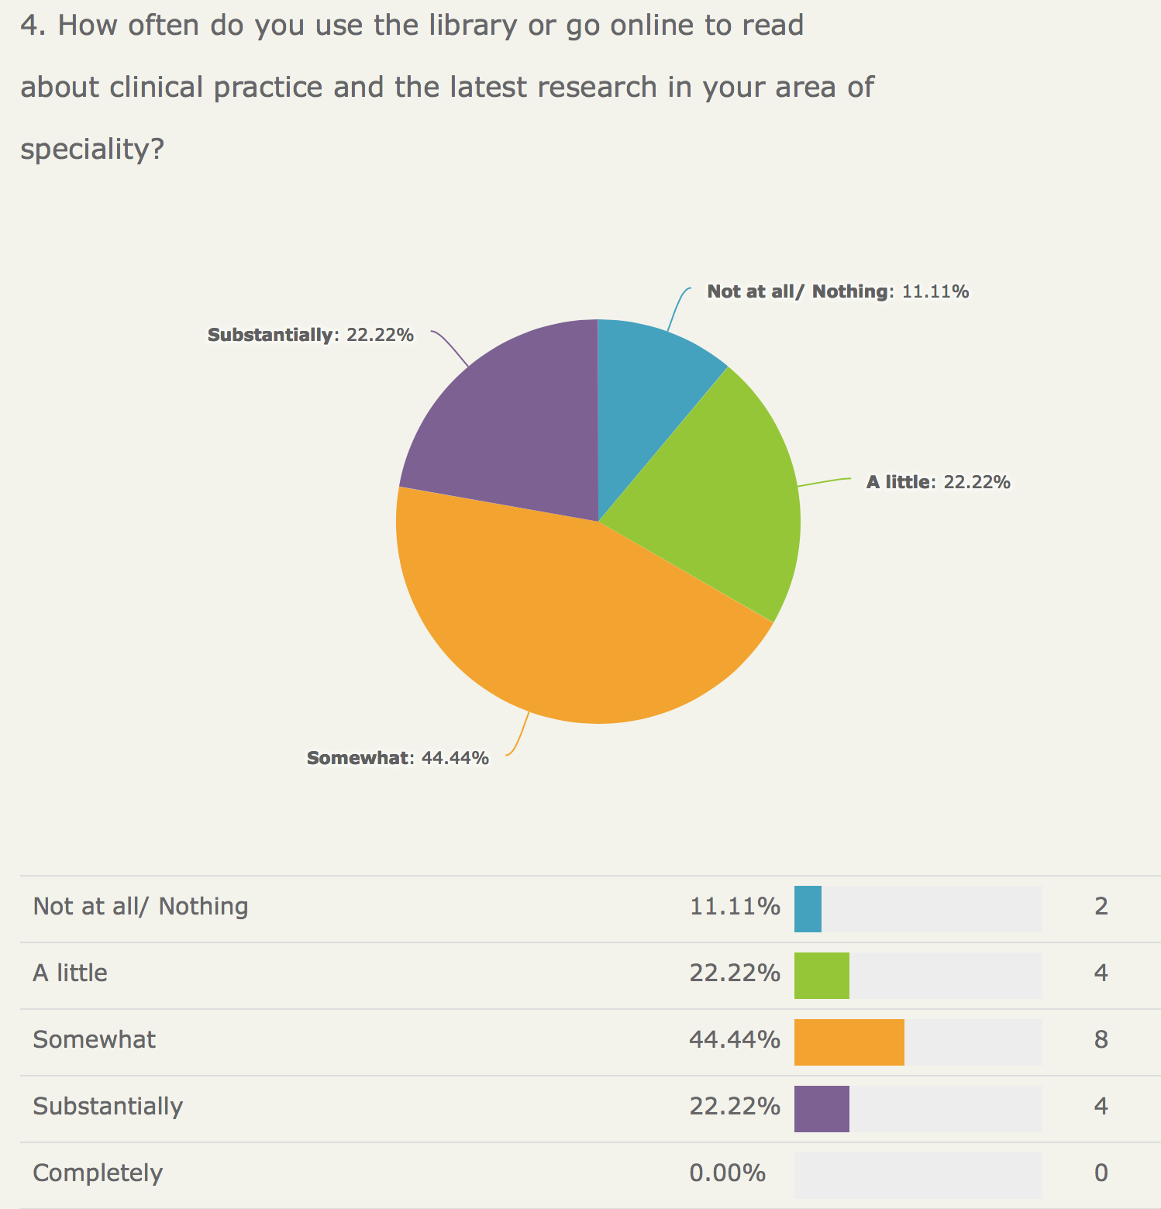

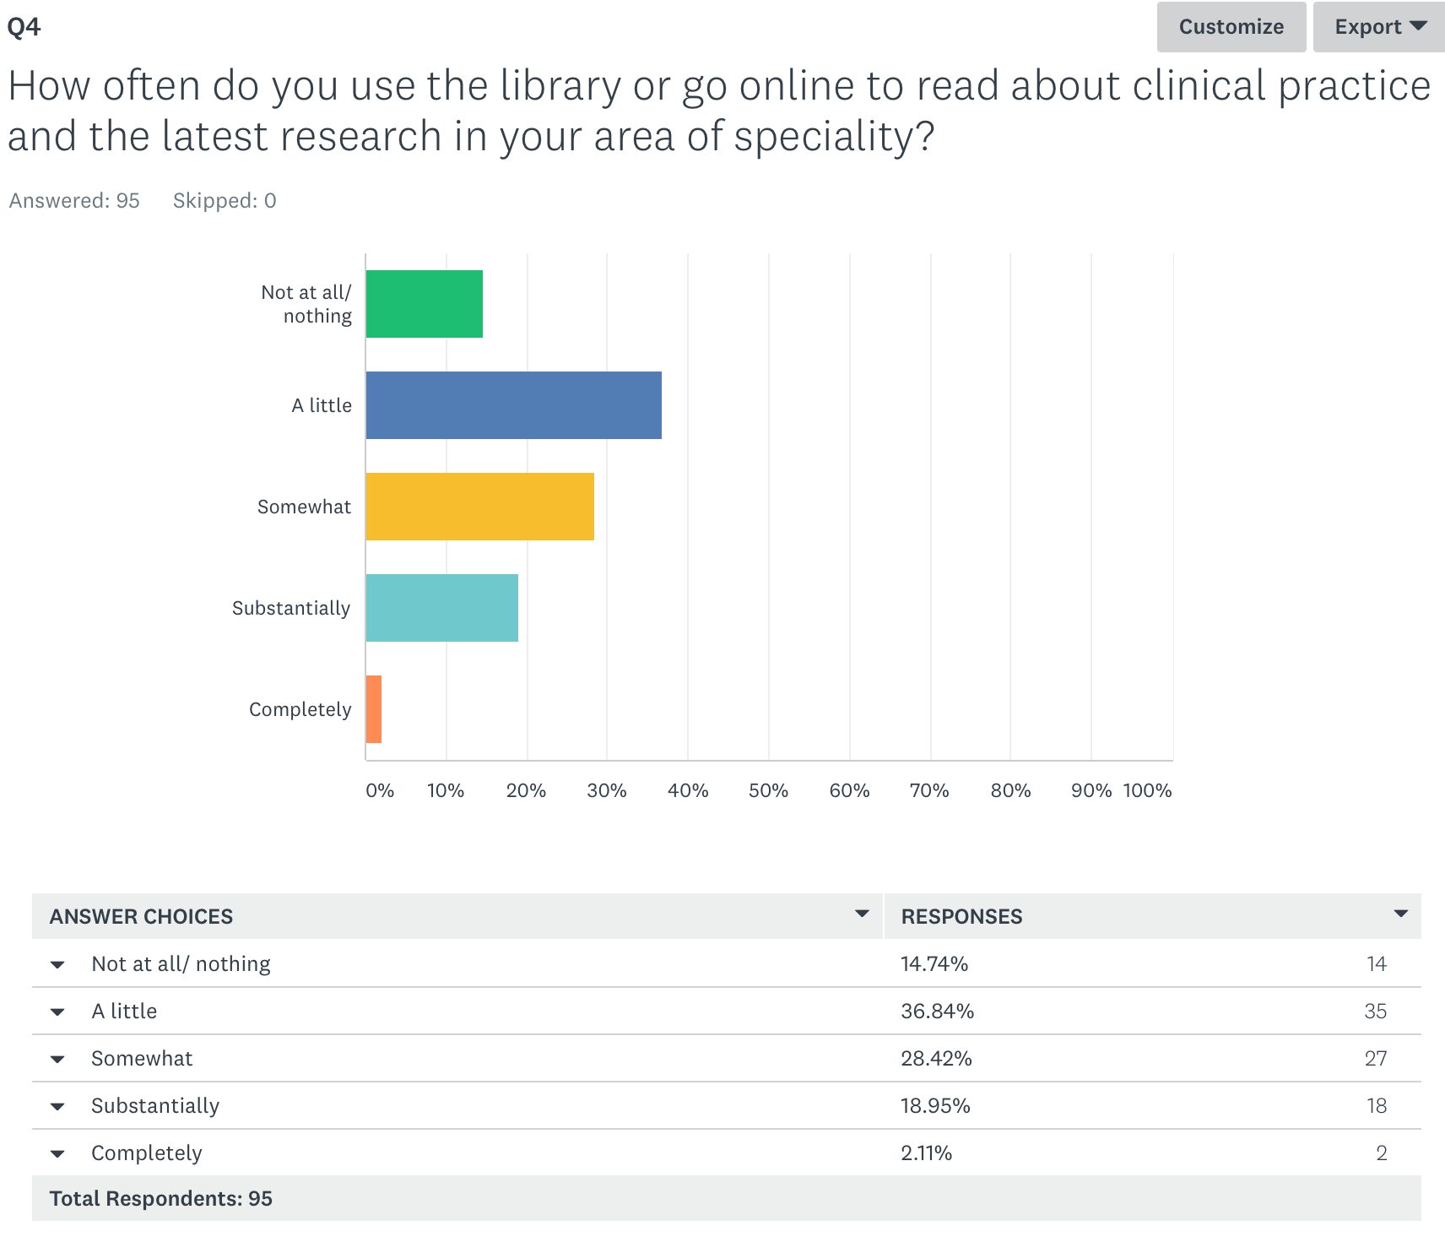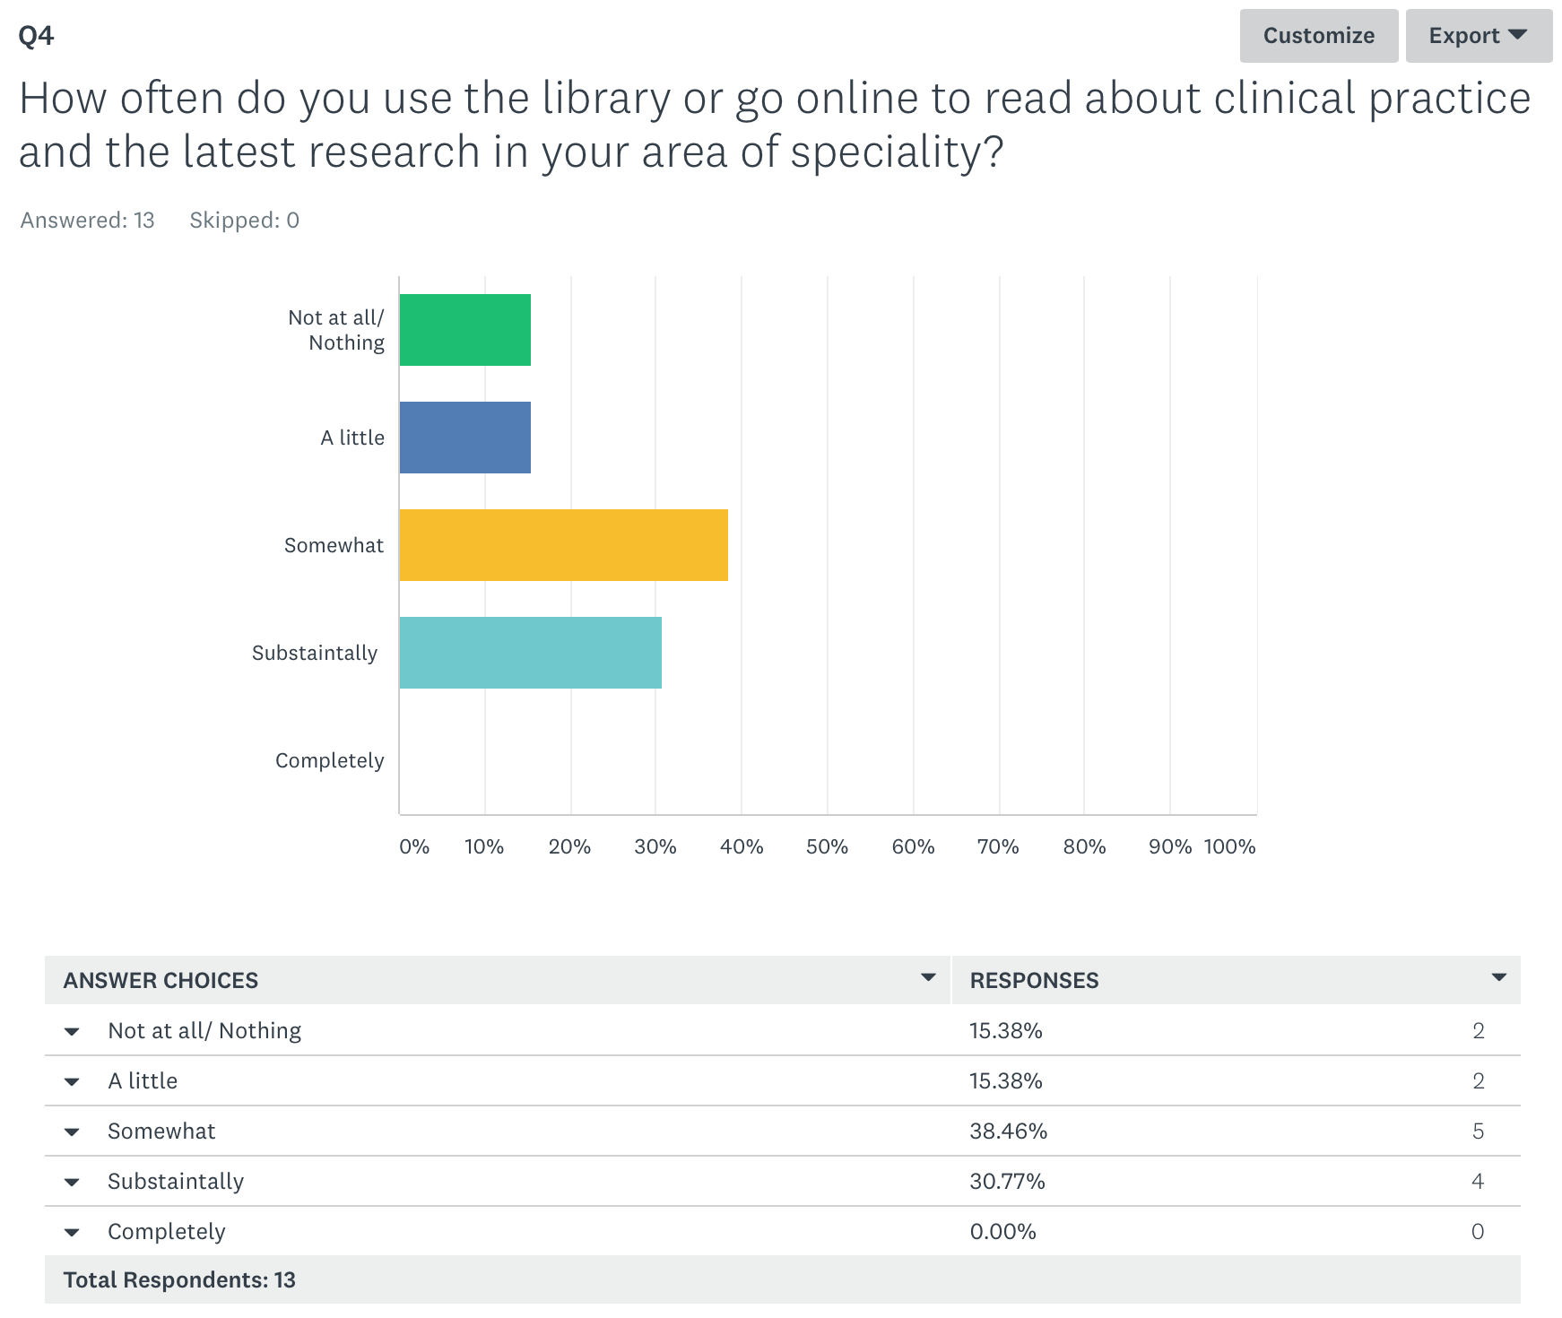
- What level of curiosity do you have about innovation and research?

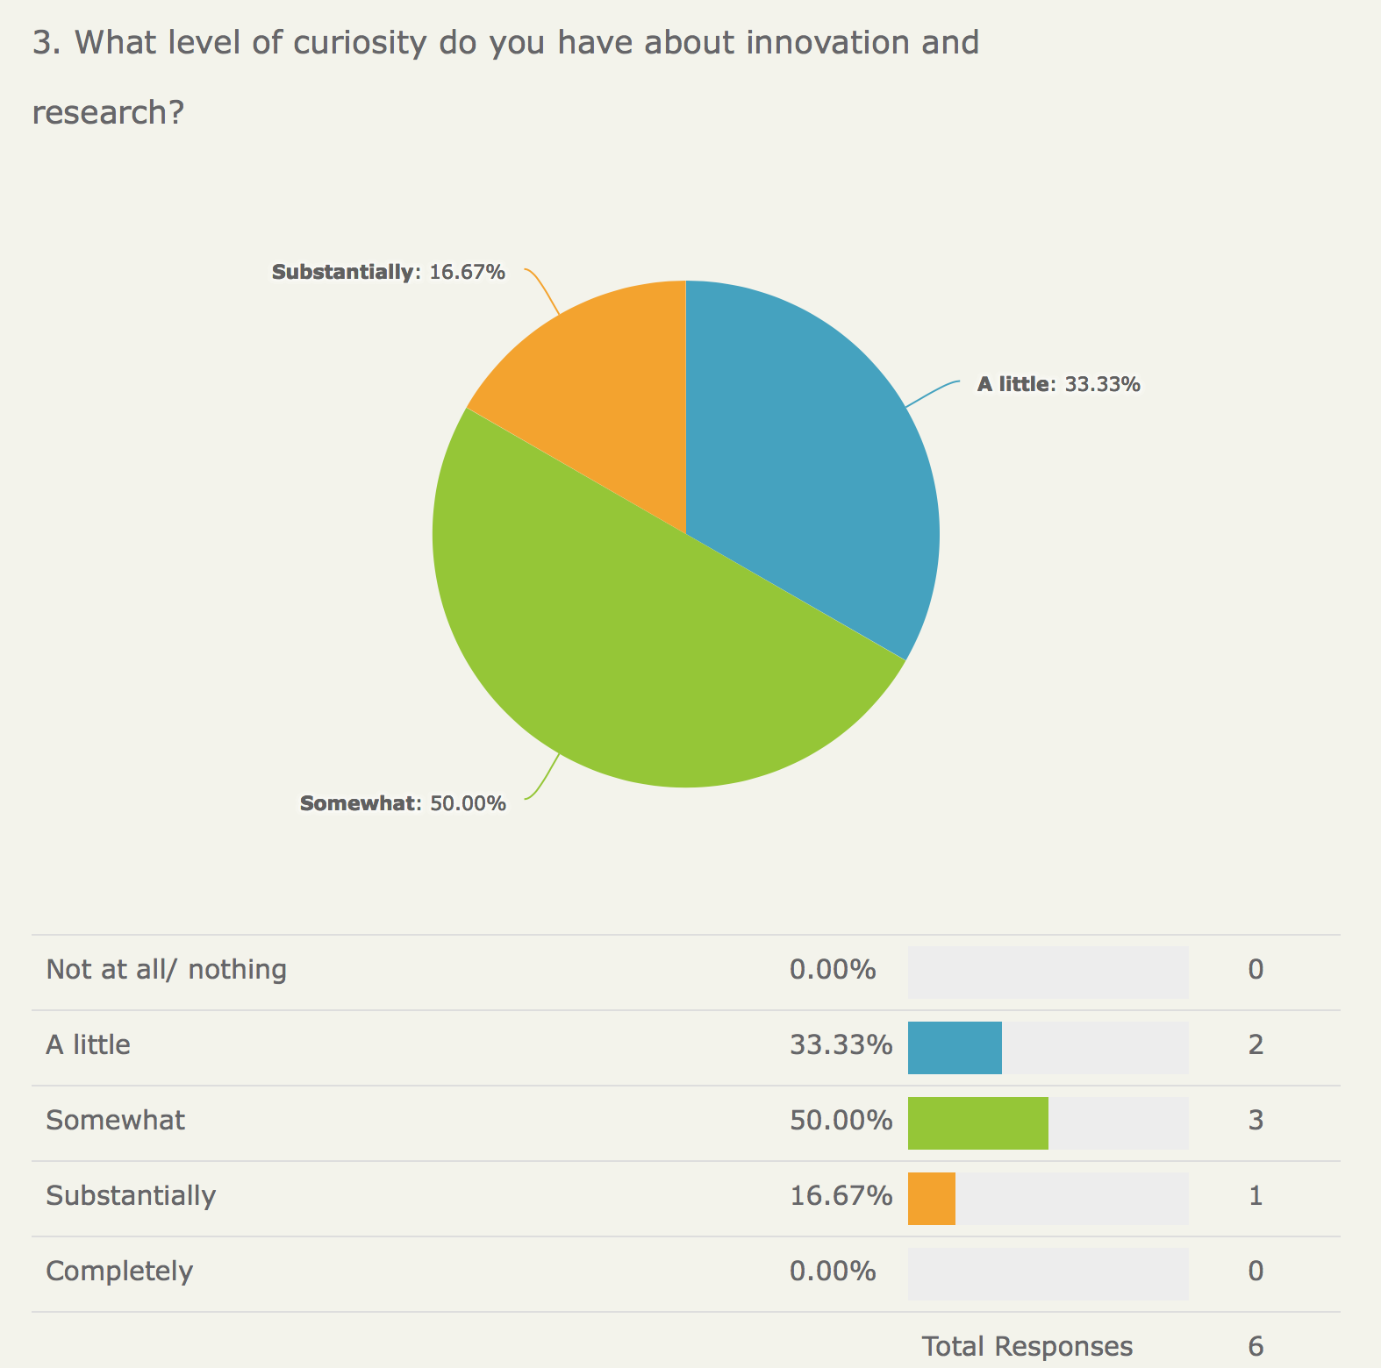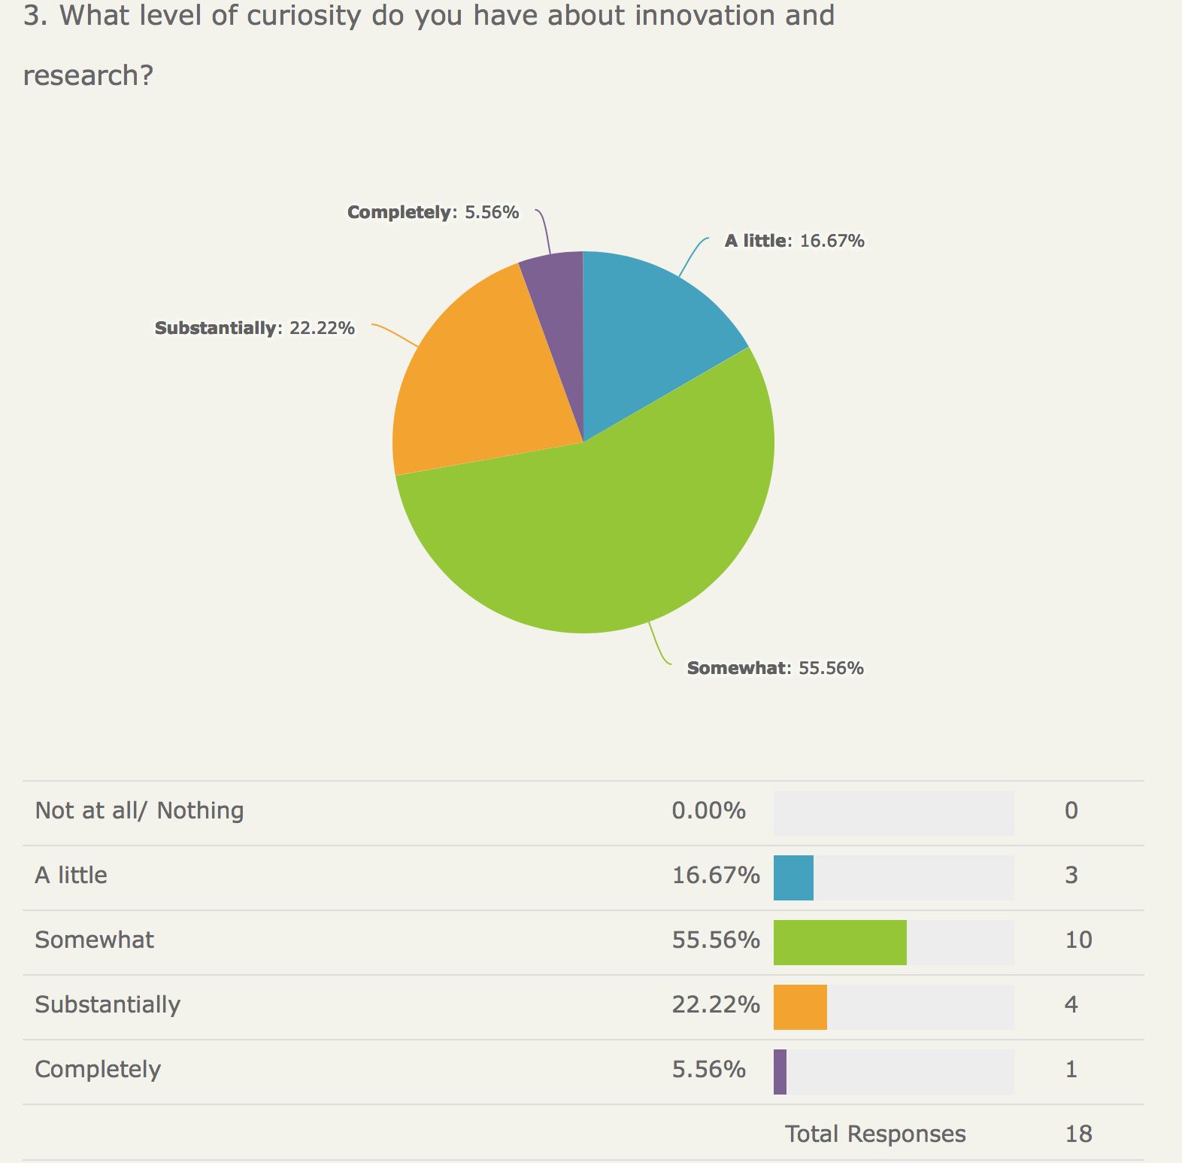

Appendix Five. Interview questions for participants.
Evaluation Interview Questions
- Why did you go on the programme?
- What have you gained from it?
- What did you find disappointing or difficult?
- Which specific parts of the programme did you get most value from?
- Have you received any feedback from others?
- How do you see it supporting your leadership going forward?

- Anything else?

