This report evaluates the NHS R&D North West team’s “North East Leading Cultures in Research and Innovation” programme delivered Autumn 2019.
NHS Research & Development North West.
Report on the evaluation of “North East Leading Cultures in Research and Innovation”
March 2020.
Compiled by Sue Roberts
POD Learning Ltd
Table of Contents
2 Executive summary 3
2.1 Programme Aims 3
2.2 Programme Outcomes 3
2.3 What participants valued most about the programme 4
3 Introduction 5
3.1 Background 6
3.1.1 Overview of the programme 6
3.1.2 Programme aims 6
3.1.3 Course outline 7
3.1.4 Participant profile 7
3.1.5 Participant pre-programme aims 7
3.1.6 Anticipated impact on the wider team from the participant’s perspective 8
4 Findings 9
4.1 Perspective of participants: 9
4.2 Perspectives of teams 9
5 Evaluation themes 13
5.1 Post programme outcomes for participants and their teams 13
5.1.1 Developing strategies and action plans 13
5.1.2 Creating new contacts and networks 13
5.1.3 Developing leadership skills 13
5.1.4 Developing a culture of research and innovation, including doing things differently 13
5.2 What participants valued about the programme 14
5.2.1 Innovative approach 14
5.2.2 Opportunity to consider own well being 14
5.2.3 Facilitation style 14
5.2.4 Network and group involvement 14
5.3 What got in the way of the participants learning effectively? 14
5.4 Future programme improvements 15
6 Conclusion 16
7 Acknowledgements 17
8 Appendix One - Overview of Day Three of the programme 18
9 Appendix Two Participant list 19
Appendix Three. Interview questions for participants. 20

Executive summary
This report evaluates the NHS R&D NW ‘Leading Cultures of Research and Innovation’ leadership development programme which ran from September to November 2019. The report demonstrates clear benefits and substantial outcomes for the participants involved in the programme, summarised below.
This innovative leadership development programme used creative experiential learning to enhance participants confidence and knowledge to lead research and innovation in their own environments.
Out of 21 participants, there was a total of 14 participant responses to a pre-programme online questionnaire, along with 93 team members, with 7 participant respondents in the post-programme online questionnaire and 8 team members responses. Four participants also participated in post programme telephone interviews. This report summarises the main findings from the surveys and interviews and identifies the key outcomes.

Programme Aims
The programme aimed to:
- Develop knowledge & understanding of national, regional and organisational R&I agendas
- Explore and increase individual understanding of how organisational cultures are formed and shaped by leaders
- Explore and develop skills and expertise to improve confidence and creativity to facilitate and lead cultures of R&I
- Have the opportunity to develop and benefit from a community of practice within their health economy
- Know how to lead an effective team based on the work of Professor Michael West [6]
- Explore how digital technology can enable communication and support healthy communities and culture within their working environment
- Be open to new ideas and ready to embrace health innovations.

Programme Outcomes
This programme hosted 21 participants from a variety of disciplines across the NHS including roles such as Senior Sister, Critical Care Consultant, Ward Manager and Lead Research Nurse.
The table below shows the pre programme and post programme responses from participants against the questions asked on the righthand side. The evaluation suggests that participants are already applying much of their learning from the programme, there are various examples of how they are now incorporating research practice into team meetings and looking to undertake further research activity both locally and nationally. Participants report increased confidence to challenge and to be able to enhance evidence-based practice.
- Knowledge and understanding of national, regional and organisational R&I agendas.
- Understanding of how organisational cultures form and the part leadership plays in this.
- Understanding of communities of practice and the benefits of being part of this?
- Knowing how to lead an effective team.
- Current level of confidence to facilitate and lead cultures of R&I.
- Your current level of ‘creativity’ in leading cultures of R&I.
- Your ability to be curious and open to new ideas and ready to embrace health innovations.

It is clear that participants have identified significant development against the first six parameters. The only slight drop is in the level of curiosity but in the scope of this evaluation it is unclear why. These outcomes can be summarised as:
- Developing strategies and action plans for implementing research and innovation into their own context
- Creating new contacts and networks
- Developing leadership skills
- Developing a culture of research and innovation, including doing things differently.

What participants valued most about the programme
Participants valued the innovative and interactive approach of the programme as well as the opportunity to network with colleagues and focus on their own well being and leadership styles.
This evaluation has found very few suggestions for development or improvement.

Introduction
This report evaluates the three-module programme of “Leading Cultures of Research and Innovation” development programme run by NHS R&D NW between September and November 2019.
The programme was evaluated with a pre-programme questionnaire for participants and their teams, then with a post programme online survey for participants as well as telephone interviews with a random sample of 20% of the participants. Team members were asked to complete a post programme survey also, only 8 completed this.
14 of the participants answered the pre-programme questionnaire. The post programme evaluation survey was completed by 7 participants.
The purpose of the report is to offer insight into the benefits and impact that the programme had on participants and to identify any areas for improvement for future programmes.
It is derived from both the pre and post survey results and the interviews conducted with 4 participants. 4 participants were interviewed via telephone using a semi-structured interview with an external researcher. (The questions forming the basis of the interviews are in appendix three.)

Background

Overview of the programme
This leadership course was based primarily on two previous programmes of work delivered and evaluated by NHS Research & Development North West.
It was a combination of a “leading clinical teams” programme funded by Health Education England [5] from 2013-2016 and the Academy of Creative Minds, an immersive programme for health researchers and professionals to work with creative artists to learn how to communicate their work more effectively and help increase its impact. Participants from these programmes demonstrated increased knowledge, confidence and understanding of the research landscape and culture and how to lead more effectively.
NHS R&D NW worked creatively with 21 middle managers from a range of clinical backgrounds to support them in leading a culture of research and innovation by building their leadership capacity to develop the skills and confidence to create an effective culture within their units, wards/departments. The focus of the training explored research and innovation culture specifically because research suggests that NHS organisations that are more research active have better patient outcomes [1]. This project design is informed by the domains of the Healthcare Leadership Model [2] and by the evaluation of the NHS R&D NW Academy of Creative Minds which was developed for the dissemination of health research but showed participation led to significant increase in individual levels of confidence, creativity and self-belief [3], skills essential to good leadership.
https://www.nihr.ac.uk/news/research-active-trusts-have-better-patient-outcomes-study-shows/2715
2(http://www.leadershipacademy.nhs.uk/resources/healthcare-leadership-model/
3 http://research.northwest.nhs.uk/work/academy-of-creative-minds/
4 A full report of this work can be found at http://www.research.northwest.nhs.uk/wp-content/uploads/2014/05/Joint-RI-Event-Oct-2013-Evaluation-Report.pdf
5 http://research.northwest.nhs.uk/publication_list/page/2/ 6 Michael A. West, 2012, Effective Teamwork: Practical Lessons from Organizational Research (Psychology of Work and Organizations), Third Edition, BPS Blackwell.

Programme aims
According to the NHS R&D website, the project was led by leadership professionals, R&D professionals, creative writers, performance coaches, magicians and somatic experts who together worked with middle managers in a blended learning approach to help them:-
- Develop knowledge & understanding of national, regional and organisational R&I agendas
- Explore and increase individual understanding of how organisational cultures are formed and shaped by leaders
- Explore and develop skills and expertise to improve confidence and creativity to facilitate and lead cultures of R&I
- Have the opportunity to develop and benefit from a community of practice within their health economy
- Know how to lead an effective team based on the work of Professor Michael West [6]
- Explore how digital technology can enable communication and support healthy communities and culture within their working environment
- Be open to new ideas and ready to embrace health innovations.

Course outline
Prior to the course, all 21 participants were invited to join an exclusive online community and start to connect with the course leaders and other course participants to share their expectations of the course and anticipated learning outcomes.
The programme began with a two-day residential. Participants were taken together on a coach, to a “secret” destination, with the aim of creating a sense of excitement but also bonding of the group as they experience the unknown together (this is a technique used by tech innovation facilitation leaders, with the venue being Lumley Castle.)
The residential was important to create a safe space for participants to learn without distraction and also to start to build both the physical and online community, which aimed to be an invaluable part of their learning journey on the programme.

Participant profile
Participants had to go through an application process to be recruited onto the programme.
They came from a diverse range of expertise and roles, with middle management responsibilities. The full participant list is in Appendix two.
Before the event, the participants and their teams were asked to complete an online questionnaire which gave an indication of their aims for attending the programme as well as their perceived current level of knowledge in several areas. Participants completed a post evaluation questionnaire but only 8 team members completed the post programme questionnaire.

Participant pre-programme aims
Participants reported a variety of reasons for attending. These can be grouped into the following themes:

Develop a clear understanding and knowledge of research and innovation
Participants reported before they began the programme that they wanted to develop their knowledge of research and how they could disseminate this to their teams and engage others in the practice of research and innovation. 11 of the 14 participants identified this as a key aim for participating in the programme. One participant commented:
“I hope the programme will develop my theoretical knowledge of research and innovation and reignite my passion to be in a position to lead this.”

Develop strategies to encourage a culture of research and innovation
Participants wanted the programme to enhance their ability to either begin to do more research within their teams, or to be able to raise the profile and value of research and innovation as a part of their role and that of their teams. One participant described it as their first time working with research as part of their role and they wanted to both:
“start and lead a research culture and importantly, create the capacity for team members to become involved.”

Develop leadership capacity and learn how to manage change
For the majority of participants, ahead of the programme, they hoped that the programme would enhance their leadership capability and increase their confidence to lead others and to lead change. The pre programme survey identified 12 participants who felt this was a key learning goal for them.

Network
The participant group had a mix of experience and roles and for many, they were looking forward to this providing an opportunity to learn from each other and to provide a network that they could link into beyond their formal programme. One participant saw this as an opportunity to share ideas and for another this was about developing links for support from both course leaders and other delegates.

Challenge colleagues
Several participants wanted to develop both their confidence and their evidence base/knowledge so that they could challenge colleagues either regarding the use of research and innovation, or to challenge higher management when they felt it was necessary. One participant hoped the programme would enable them to:
“give me the confidence to challenge higher management when problems arise….. To be a voice for my team and to act on their behalf… to be seen as a source of support for team members”

Anticipated impact on the wider team from the participant’s perspective
Participants were asked in what they hoped that attendance on the programme would support their teams
5 of the 14 participants believed that the programme would enable the team to participate more in research and innovation, with 4 hoping that the teams would be better positioned to evidence their practice and as 3 people commented, this would:
“ultimately lead to improving the quality of care and decisions will improve and staff will feel more informed and empowered.”

Findings
The graphs and diagrams in the following section demonstrate the pre and post programme perceptions of levels of knowledge and expertise from both participants and their team members in the following areas:

Perspective of participants:
Participants were asked to self-score on a scale of one to ten, ten being ‘completely’, one being ‘not at all’ against the statements listed below.

Key: Green: Pre-programme responses
Grey: Post programme responses
The questions compared above are what the participants scored themselves against as listed below:
- Knowledge and understanding of national, regional and organisational R&I agendas
- Understanding of how organisational cultures form and the part leadership plays in this?
- Understanding of communities of practice and the benefits of being part of this?
- Knowing how to lead an effective team based on the work of Professor Michael West.6
- Current level of confidence to facilitate and lead cultures of R&I
- Current level of ‘creativity’ in leading cultures of R&I
- Ability to be curious and open to new ideas and ready to embrace health innovations.

From the results above, it is clear that participants found the programme had developed their skills and knowledge significantly. This is backed up by many of the statements from the participants. As one participant commented:
“my organisation isn’t one where research is well known and unless you know who to contact, it can be hard to get anywhere. This programme gave me the knowledge of the research structure in the North and pointed me in the right direction.”

Perspectives of teams
Responses from team members before the programme are displayed on the left, with the post programme responses on the right had side for the following six questions. It is important to note that there were 93 team member questionnaires completed before the programme, and 8 completed post programme. Therefore, it must be taken into consideration how much of an accurate reflection of wider team views, the scores below represent. However, those that completed the questionnaire on the whole reported improvement in their response to all the questions post programme, with one exception, working as a team. The responses will be discussed in more detail below.
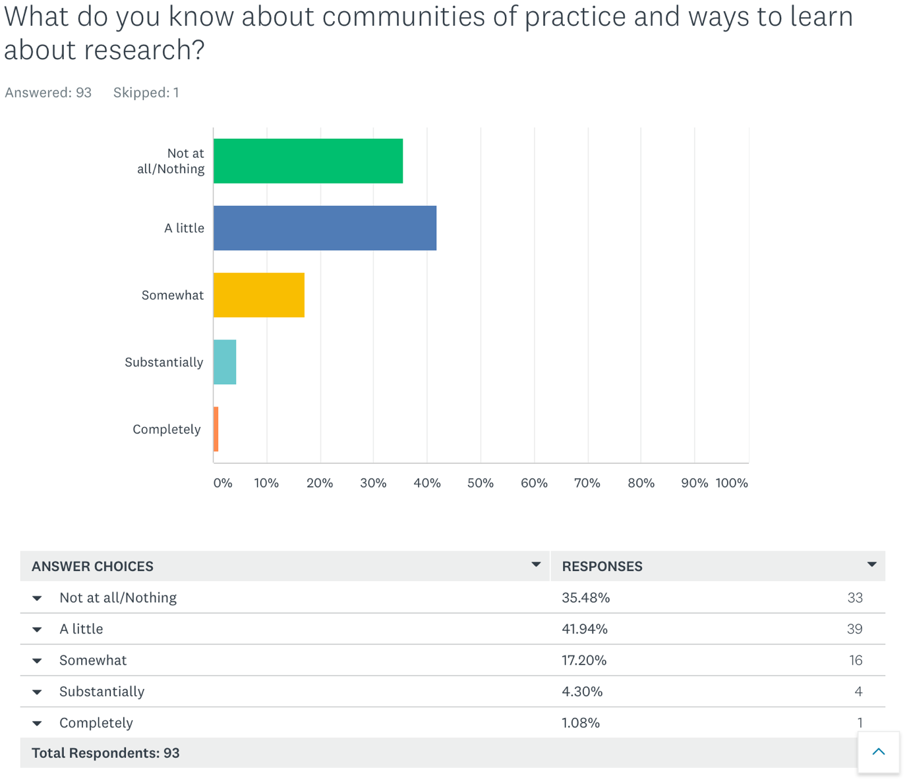
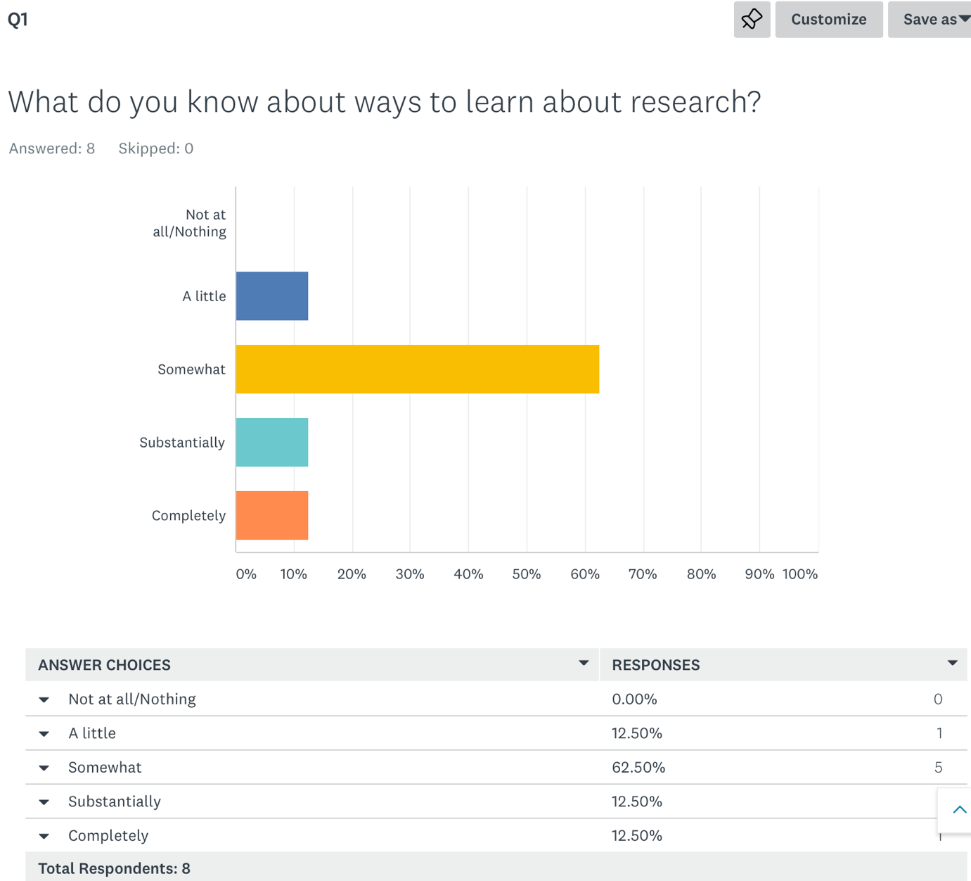
The response to the question above suggests that team members have a greater level of knowledge about how to learn about research, with none reporting knowing nothing after the programme, and an increased percentage reporting they now know somewhat, substantially or completely. This suggests that learning from the programme has been transferred to team members that responded.

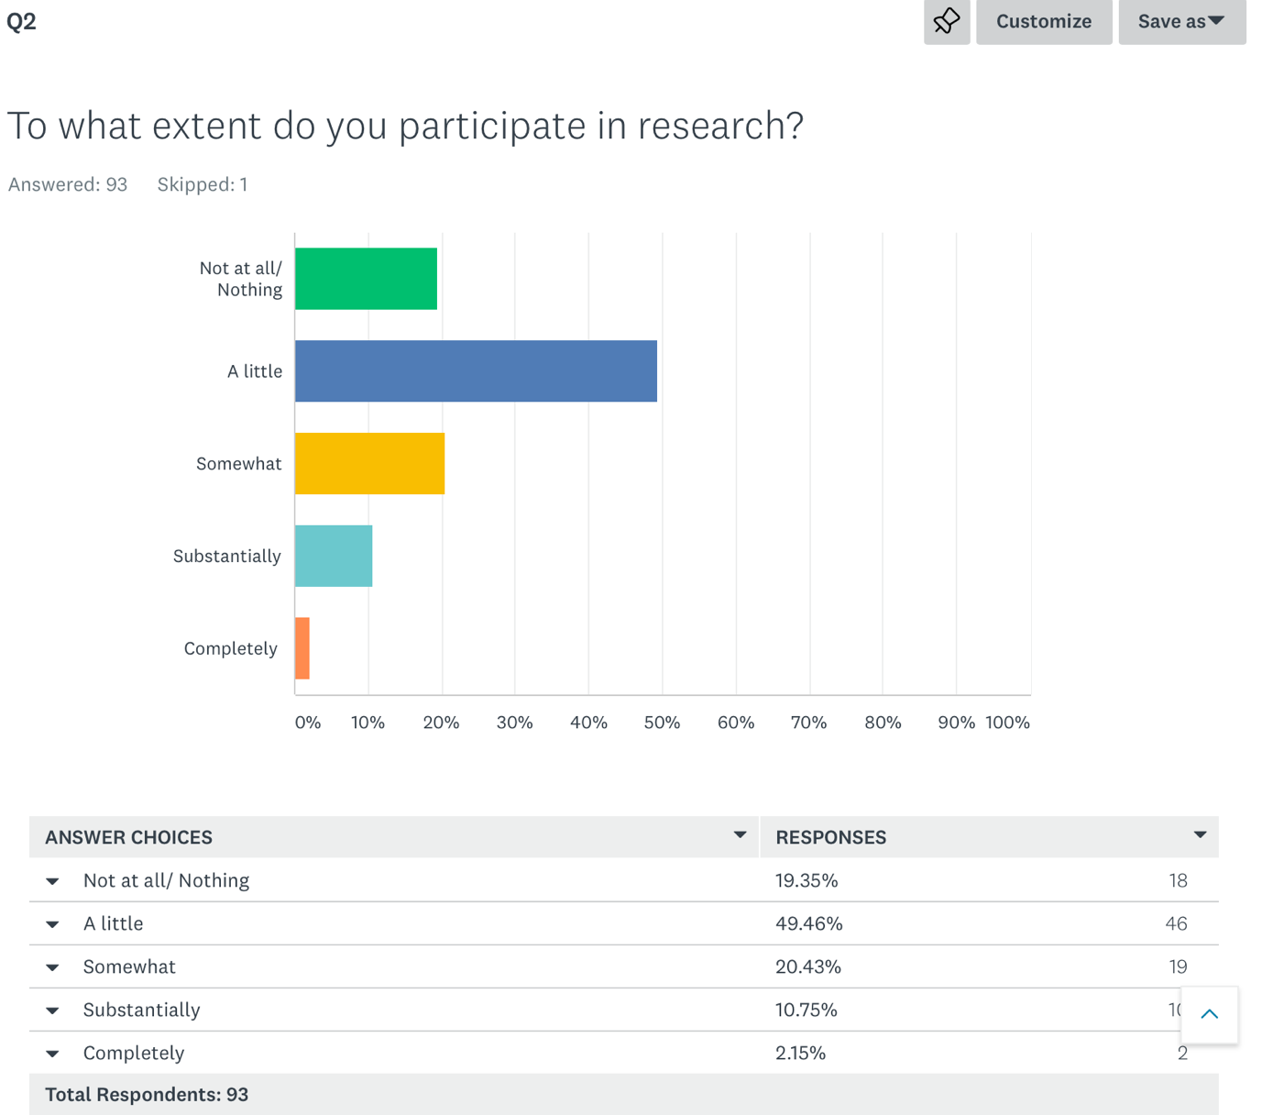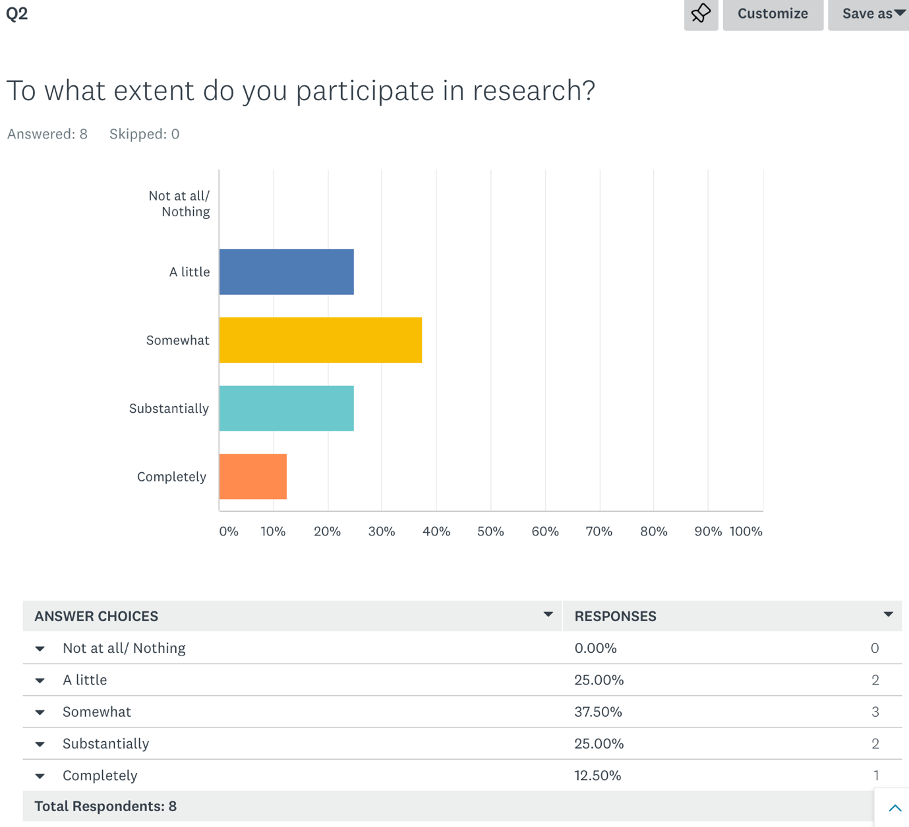

It would appear that the 8 team members who responded to the post questionnaire feel they have a greater level of contribution to research, with no one reporting no involvement compared to the pre programme survey.
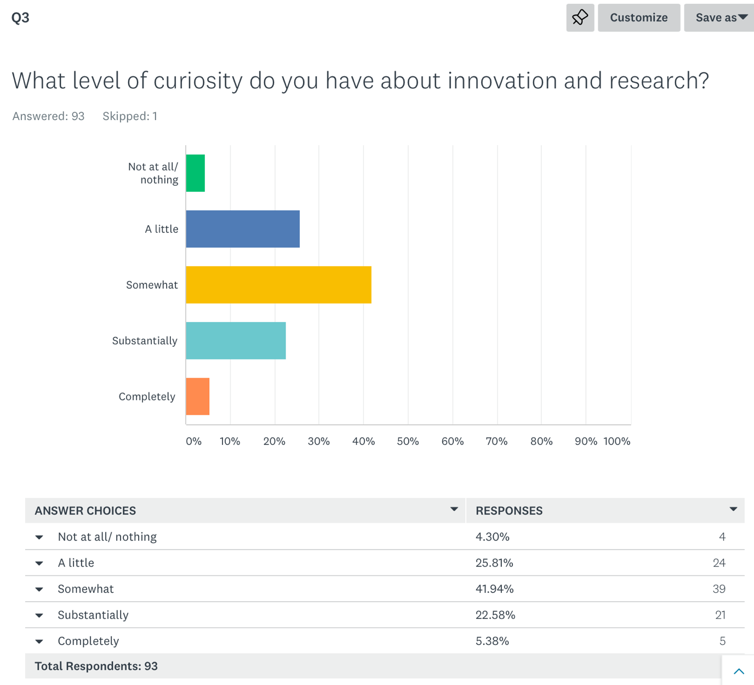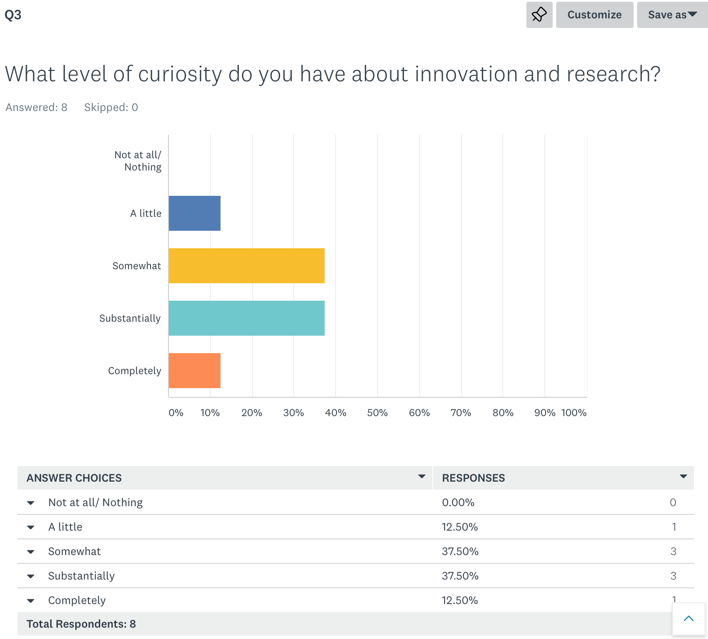
The graphs above suggest that levels of curiosity towards innovation and research have grown for team members after the programme with more reporting substantial or complete curiosity than before the programme.

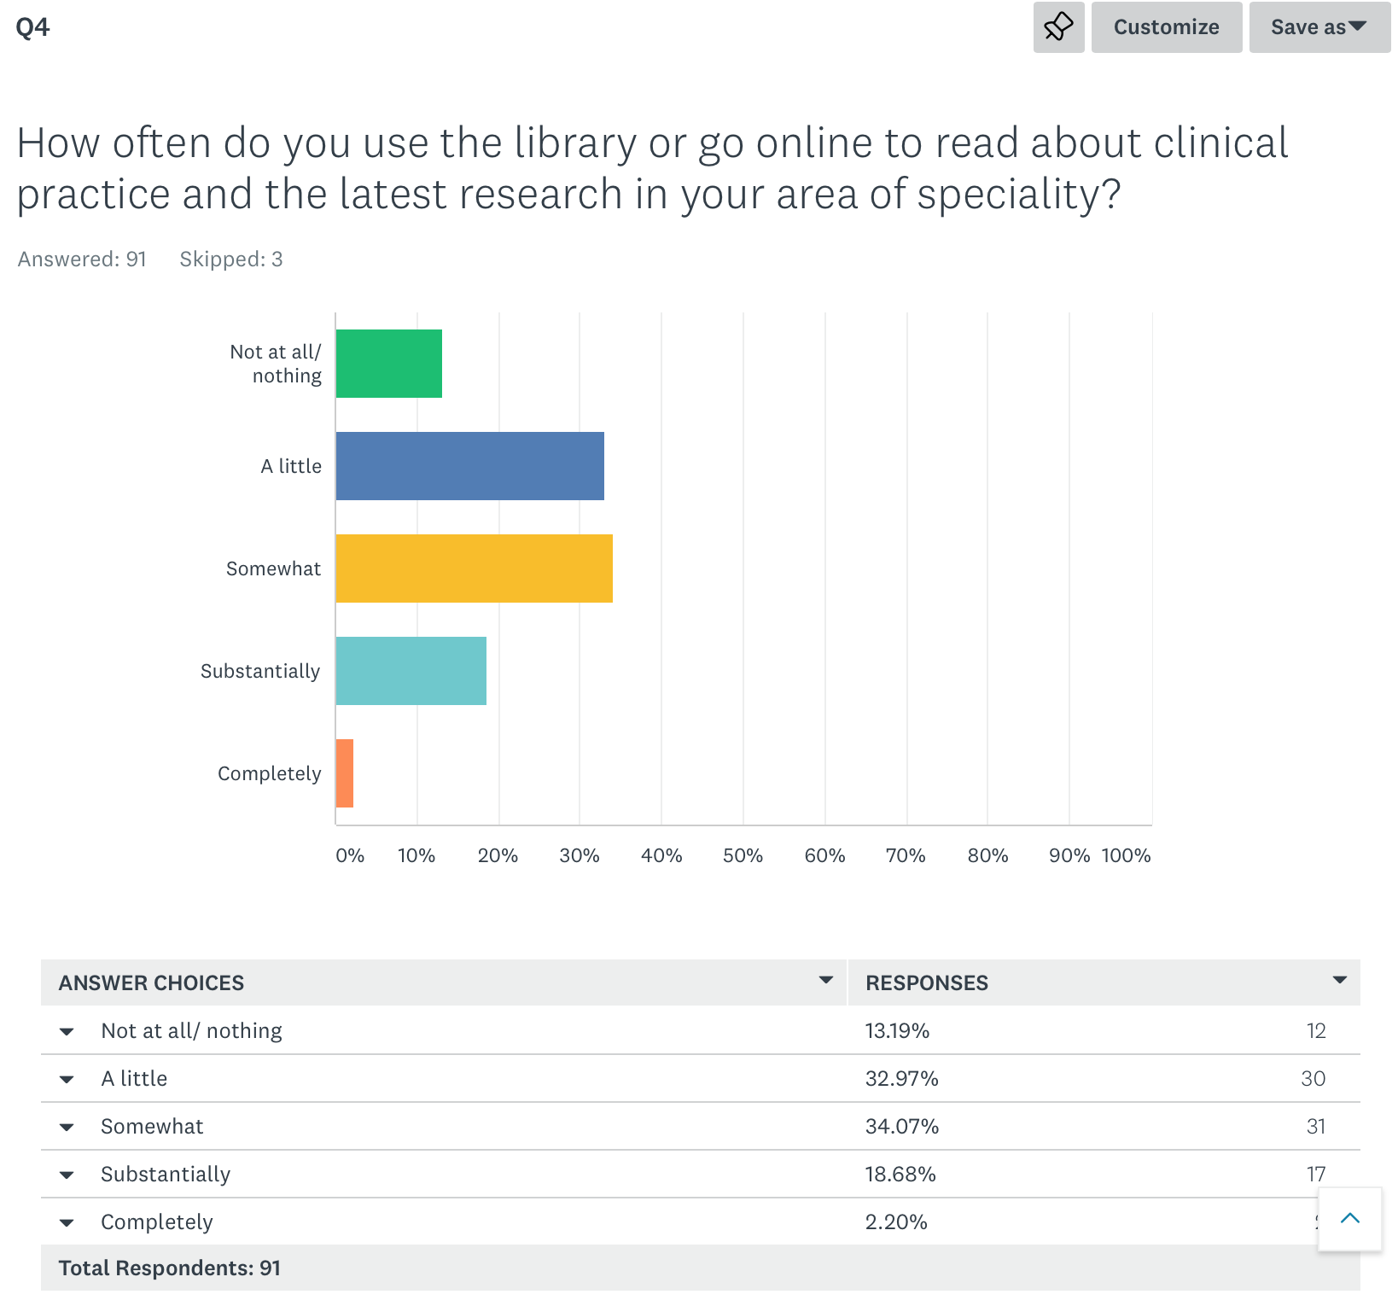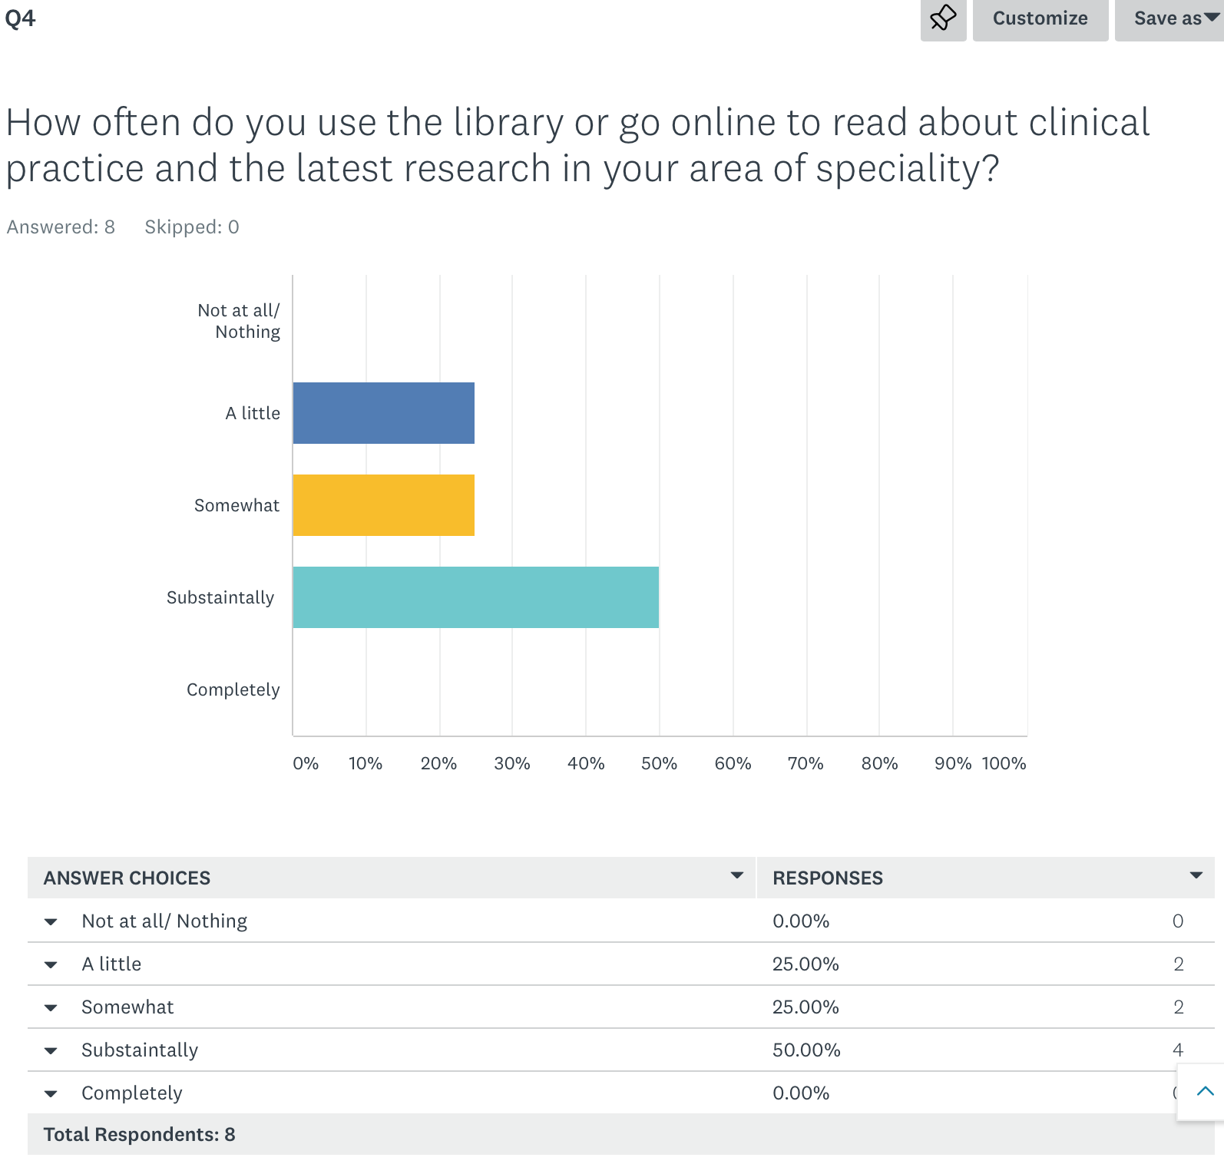
Team members have increased their usage of the library after the programme, with 50% reporting using the library substantially compared to only 18% before the programme.

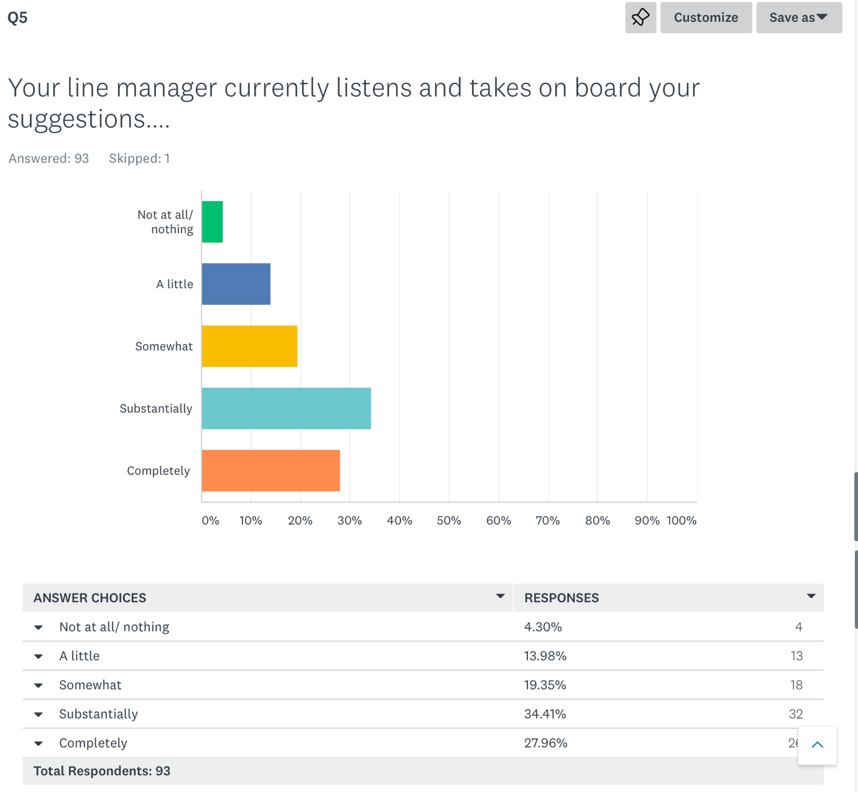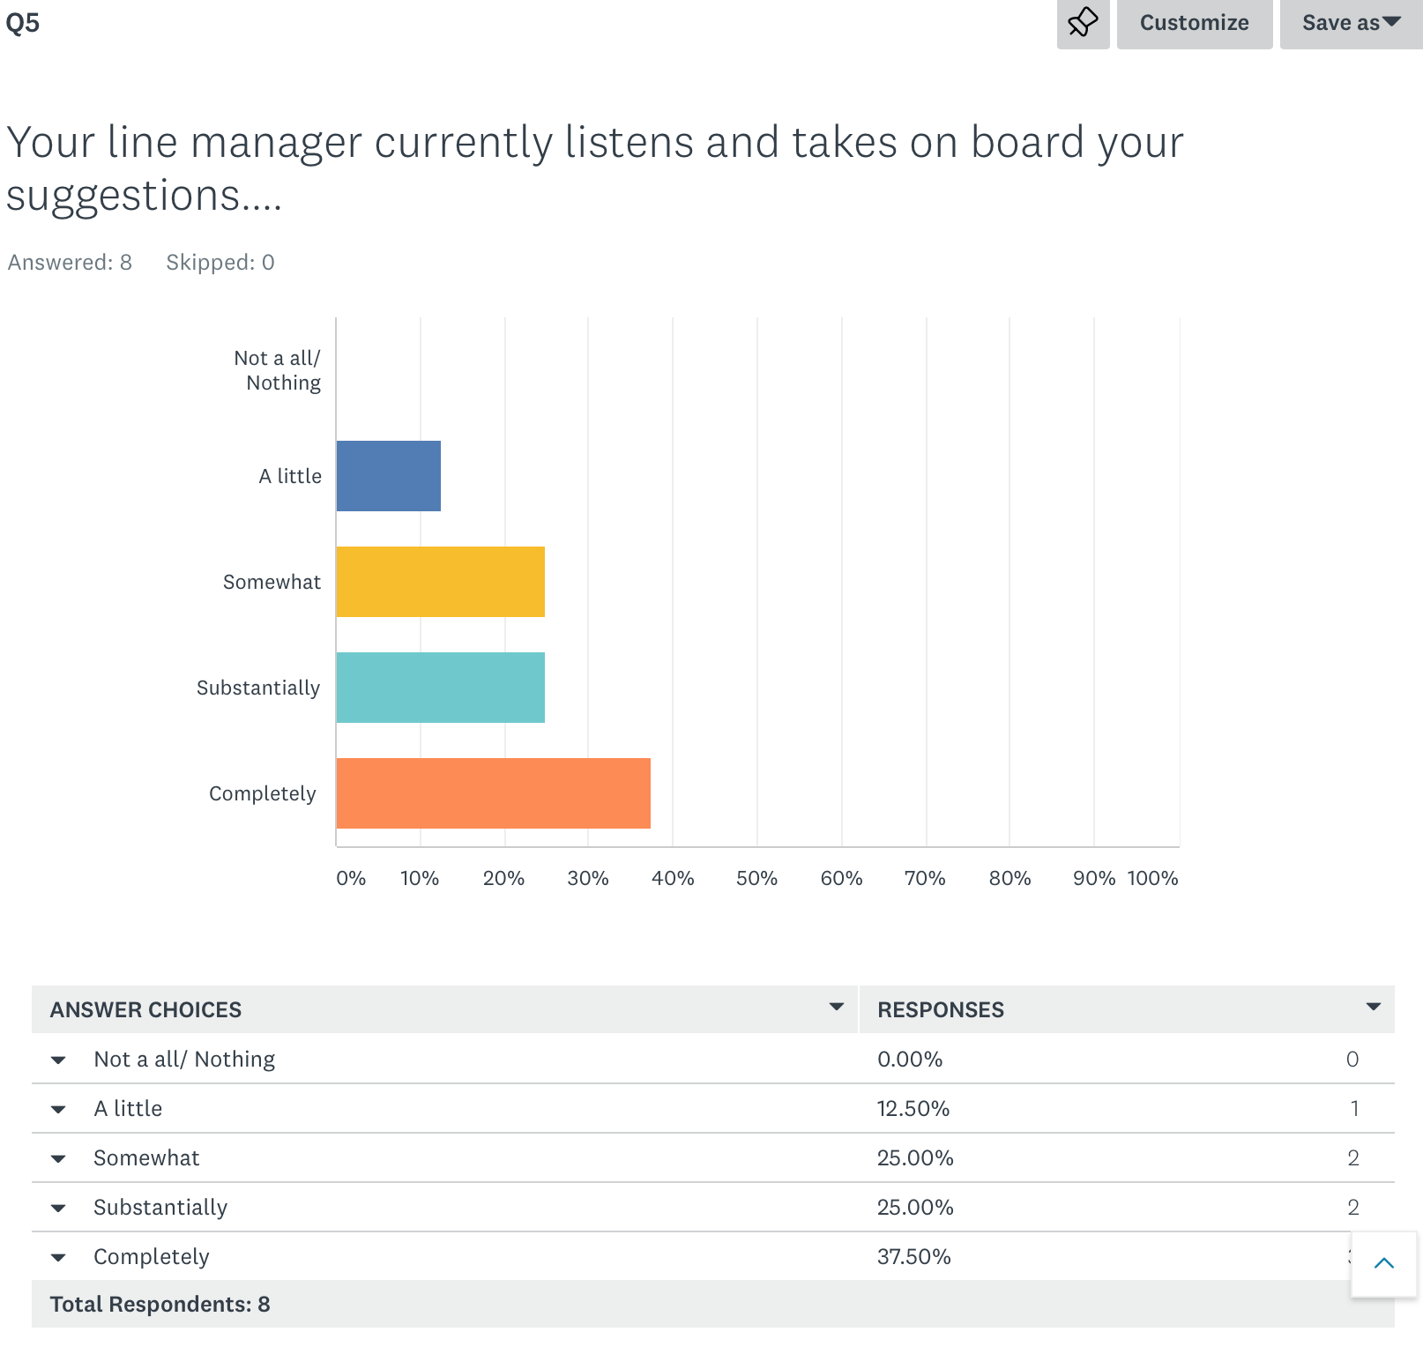
After the programme, it appears that team members may feel that their line manager listens to the, with a reduction to 0 for team members not feeling listened to at all, and a rise from 27.96% of team members feeling completely listened to before, to 37.5% feeling completely listened to after the programme.

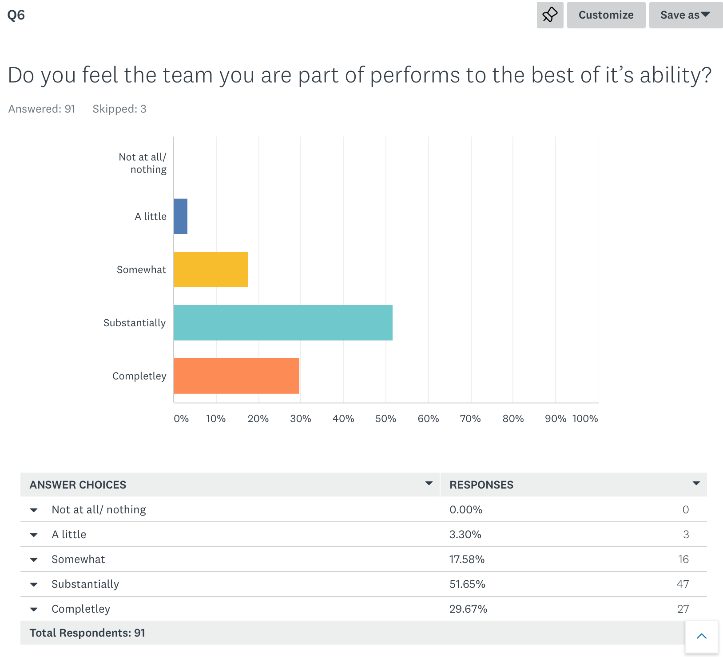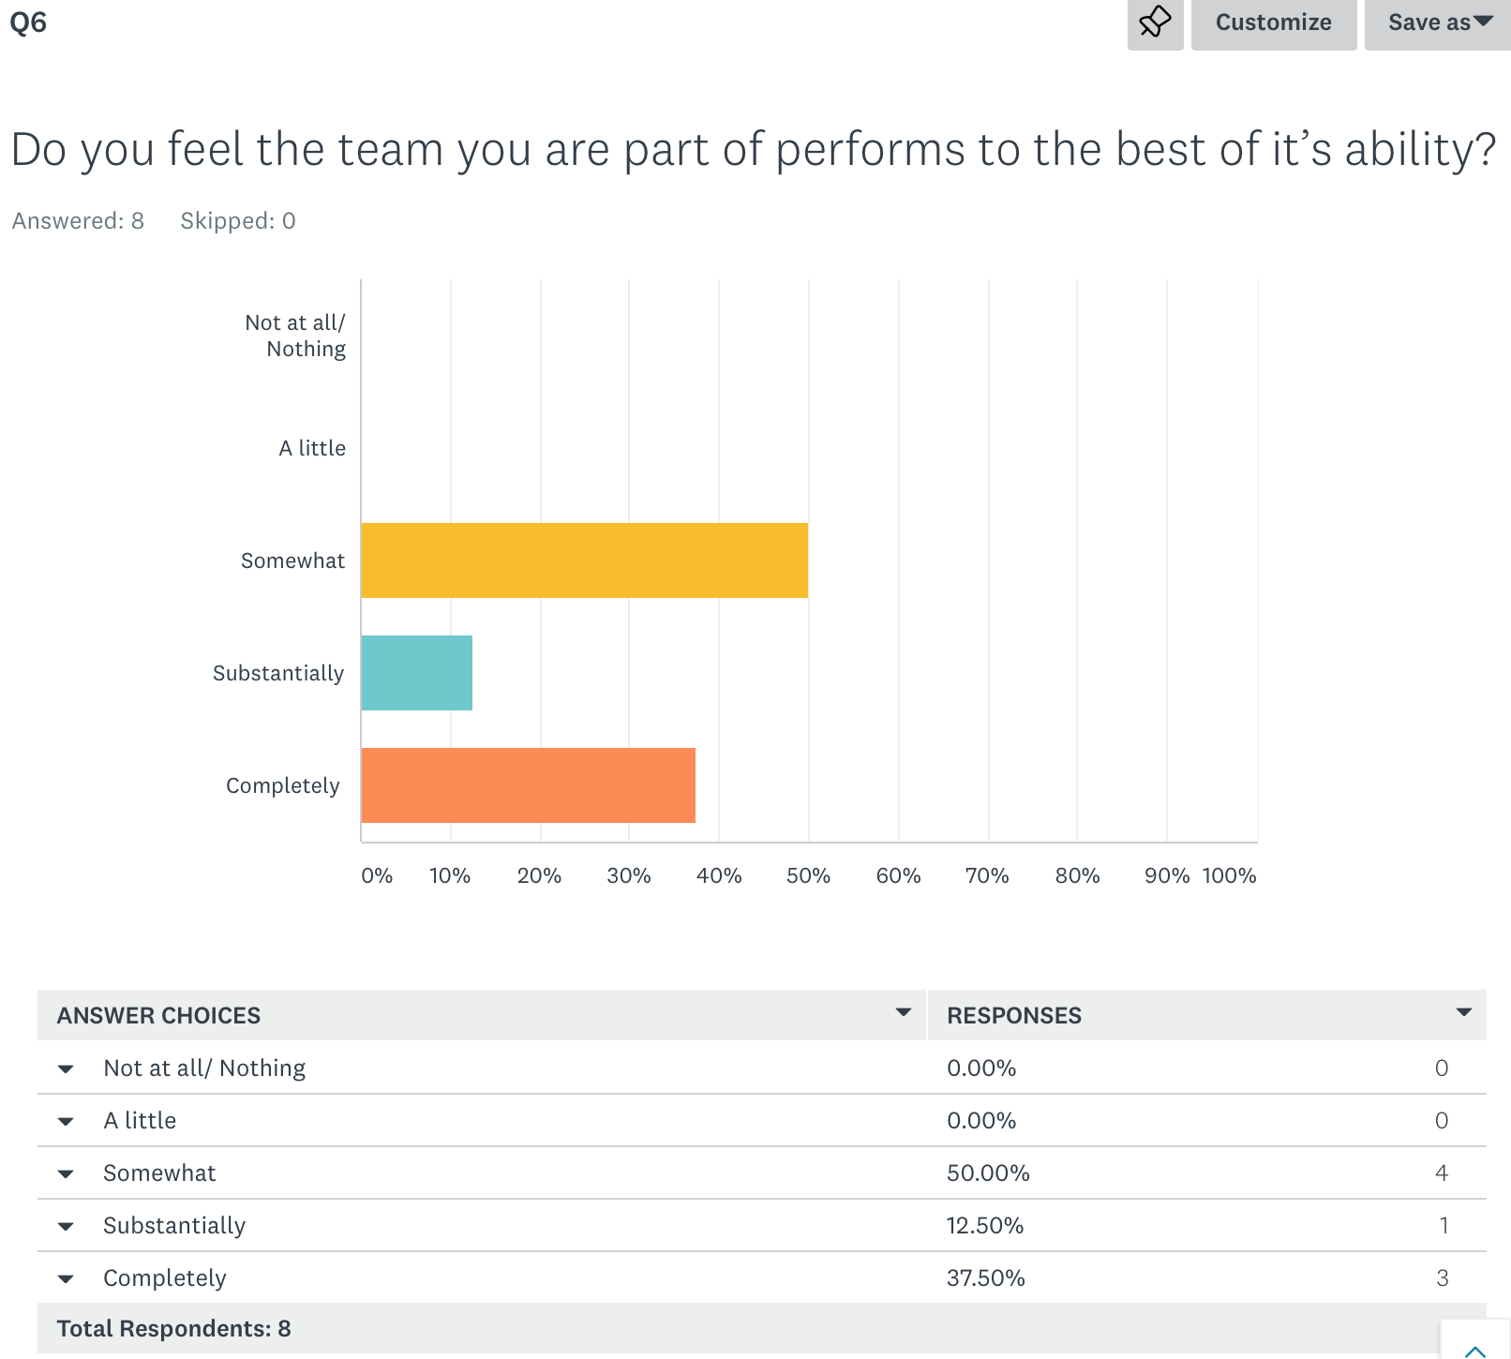
In the final question above, team members have increased their sense of the teams ability to perform to it’s best completely from 29.6% to 37.5%, with a greater number of team members also reporting this to be somewhat true. No team members disagree with the statement after the programme which suggests an improvement, although with this graph that improvement is marginal. It is important to note that with this question, we do not know what factors other than participant attendance on the programme may have influenced people’s views of whether they are able to work effectively as a team or not.

Evaluation themes
From the post programme survey with 7 participants and 8 team members, plus 4 interviews with participants during February 2020, four months after conclusion of the programme, the following themes have been identified.

Post programme outcomes for participants and their teams

Developing strategies and action plans
In the participant survey and interviews, the most regularly reported outcome for participants (6 people) was that they now had action plans to develop research and innovation within their role, team and department. For several of the participants interviewed, they had already implemented a number of actions from these plans including:
- Attending specific research meetings within their Trust or area of expertise
- Developed monthly meetings for colleagues and/or made research and innovation an agenda item on their team meetings
- Developing and/or have begun research projects – for example, one of the participants is currently scoping a research project for safeguarding nationally looking at working with a young person group.

Creating new contacts and networks
The 2nd most often cited outcome for participants (4 people) was that they had developed networks which would support them in embedding research and innovation. For one participant, it had enabled them to connect with other Trusts and Research specialists, through the help of the NHS R&D team so that their research can be more widely disseminated and to connect with other Research Managers across the North West of the UK.
For participants it was also an opportunity to hear different perspectives from colleagues working in different parts of the NHS, and one participant felt this was invaluable in giving them a broader perspective, empathy and insight into other roles and their challenges.

Developing leadership skills
Participants valued the opportunity to self-reflect and to understand more about their own leadership styles. For those who hadn’t undertaken the leadership assessment previously, they reported this had helped them to develop greater awareness of their own styles. For one participant they reported that they now “understand my priorities more and have become more aware of my leadership and where I need to work.”
One participant identified that it had enabled them to have more ideas on how to lead others and how to influence and lead change.
For several of the participants they felt it had equipped them with greater confidence to challenge senior management if needed to get things done and be heard.

Developing a culture of research and innovation, including doing things differently
Participants reported that they now have more tools to develop and implement more research into their roles and their teams. One participant commented that the programme had:
“reignited my passion to study more, after 15 years of not doing any study. Since the programme has finished, I have embarked on further study and have just finished a 4 week online course on research awareness and I am signed up for further courses.”

What participants valued about the programme

Innovative approach
Participants reported that the style of the programme was a “breath of fresh air” because it was creative and participative. In the survey, the programme was described as “creative” “exciting” and “interactive”. They valued the experiential activities such as an exercise with lego as a different way of learning. One participant is now using ‘notability’ as a different way of presenting to his team and colleagues.

Opportunity to consider own well being
The participants interviewed as part of this evaluation described the value of working on their own well being and using the concept of mindfulness, despite admittance by some that they were initially sceptical. Several reported that it has helped them to find ways to continue to look after themselves beyond the programme.

Facilitation style
The participants interviewed found the facilitation style helped them to learn and to be at ease. All of those interviewed described the style as informal and one commented that they were “disarmed by the easy-going attitude”.
One participant highly valued the connections that the facilitators made for them beyond the programme to support them disseminating their research, whilst for another it was the commented specifically on Jana, one of the facilitators, saying:
“Jana stands out. She is a very expressive person and positive, a ray of sunshine. I have been influenced by her energy and passion. It has shown me that this behaviour can influence others. I really appreciated her.”

Network and group involvement
Participants valued the opportunity to meet colleagues from different disciplines within the NHS and to share ideas and learning. One participant felt that it had changed their perspective on the roles other undertake and they had much more empathy for them in the role than they had previously. There was an element of knowing who to connect with to develop research agendas and this linked with a growing desire to do this and inform others of how to do it and the value of it.

What got in the way of the participants learning effectively?
Participants were asked what got in the way of them learning or applying their learning effectively. Most could not highlight anything that got in the way. Most reported that the biggest problem was with finding time to apply the learning or to devote to research when they are in their own environment. However, it appears they have implemented many aspects of their learning in their own practice already.
One participant felt that they were still not clear regarding innovation and that this area was less likely to be on their agenda than the research element. Whilst another participant mentioned the challenge of technology and felt that their own level of experience with Twitter and 5G meant that they struggled with this element more.

Future programme improvements
Innovation has been reported as the element of the programme that the participants found more confusing, although this was only the least understood aspect of the programme of a very satisfied group of participants. It is worth considering how this can be simplified or made more pragmatic still for future programmes.

Conclusion
21 participants completed this programme, of which 8 completed the post programme online questionnaire and 4 were interviewed. From this population, feedback on the programme is highly positive. Participants have already applied aspects of their learning and are delivering their practice differently, with the introduction of research on team agendas one of many examples discussed.
The creative and interactive nature of the programme was highly valued, especially the opportunity to consider their own well being and to learn how to look after themselves through practices such as mindfulness.
The original aims of the programme were to:
- Develop knowledge & understanding of national, regional and organisational R&I agendas
- Explore and increase individual understanding of how organisational cultures are formed and shaped by leaders
- Explore and develop skills and expertise to improve confidence and creativity to facilitate and lead cultures of R&I
- Have the opportunity to develop and benefit from a community of practice within their health economy
- Know how to lead an effective team based on the work of Professor Michael West [6]
- Explore how digital technology can enable communication and support healthy communities and culture within their working environment
- Be open to new ideas and ready to embrace health innovations.
This evaluation concludes that the aims appear to have been addressed through the interviews and survey data from participants and their team members.
As one participant described her view of the programme:
“I want to shout about this programme from the roof tops, we talk about evidence-based practice and this course gives you the tools to do it. It has ignited my passion for research and innovation.”

Acknowledgements
Thank you to Gillian Southgate who provided insight into the programme and to Leanne Gregory, who organised the collation and administration of the online surveys and contact details for the interviewees. Also, thank you to all of the team members and participants who completed the surveys and to the participants who took time to be interviewed; Michelle Milburn, Girenda Sadera, Karen Jardine and Yan Cunningham.

Appendix One - Overview of Day Three of the programme

Leading a Culture of Research and Innovation

Thursday 24th October, Beamish Hall Hotel
Programme of the Day

Day 3 – Influencing and Connection
8.30 Arrival, tea & coffee
9.00 Warm up
9.15 Influencing Styles
10.15 Reflection
10.20 Coffee
10.30 Networking exercise
11.00 Guest speakers – world café style
12.30 Lunch
1.15 Preparing the body for presentation (embodied leadership model)
2.15 Reflection & Coffee
2.30 Exercise with Stuart Nolan
4.00 Preparation for day 4, questions and feedback
5.00 Finish

Appendix Two Participant list
Name | Job Title | Organisation
Girenda Sadera | Consultant Critical Care, Lead for research | Wirral University Teaching Hospital
Allison Heathcote | Senior Sister | Newcastle upon Tyne Hospitals NHS Trust
Angela Brownbridge | Clinical Manager | Northumberland Tyne & Wear NHS Foundation Trust
Nicola Reynolds | Clinical Team Leader | North Tees & Hartlepool NHS Trust
Michelle Milburn | Safeguarding Children Nurse Advisor | South Tyneside and Sunderland NHS Foundation Trust
Joanne Kerr | Senior Sister | Newcastle upon Tyne NHS Foundation Trust
Elaine Prosperini | Senior Sister | Newcastle upon Tyne NHS Foundation Trust
Eileen Baker | Clinical Dietetic Manager | Newcastle upon Tyne Hospitals
Helen Sanger | Advanced Physiotherapist | Newcastle upon Tyne Hospitals
Anne Boulton | Team Manager | Northumbria Healthcare
Kirsty Jones | Advanced Practitioner | South Tees NHS
Yan Cunningham | Orthopaedic Nurse Practitioner/Research Nurse | Sunderland Royal Hospital
Lorenda Casling | Advanced Nurse Practitioner | Tees Esk and Wear Valley NHS Foundation Trust
Lisa Parker | ASSOCIATED NURSE CONSULTANT | TEES ESK AND WEAR VALLEY NHS
Lee Hardy | Ward manager | County Durham and Darlington Foundation Trust
Bev Thompson | Team Manager | Tees Esk and Wear Valley
Karen Jardine |  | Tees Esk and Wear Valleys NHS Foundation Trust
Andrea Haydon |  | NTW Foundation Trust
Michael Shaw | Senior Charge Nurse | Gateshead Health NHS Foundation Trust
Victoria Pye
Nicola Cunningham | Lead Research Nurse | South Tees NHS

Appendix Three. Interview questions for participants.
- Can you describe a little about your background and role please?
- Why were you attracted to the programme?
- What was the experience like for you?
- What impact has the programme had on you/ your team/your work?
- What has had the most impact for you?
- What got in the way of your learning?
- How was the balance between leadership development and innovation and research
- What will help you to apply your learning?
- What can get in the way of you applying the learning?
- What do you think could improve this programme?
- What are you telling colleagues and managers about the programme and the learning?
- What are your next steps now following the programme.
- Any other comments?

