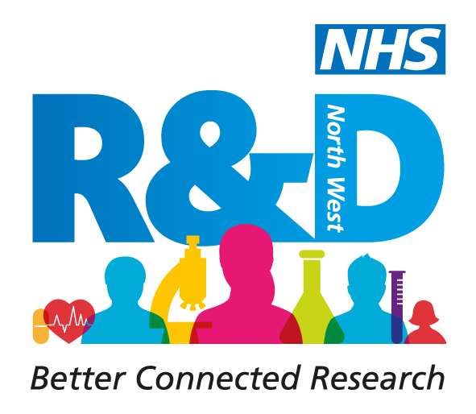
NHS Research & Development North West Conference
Let’s Talk Research 5, 25th June 2020
The Monastery, Gorton

Abstract Submission Form for Research Has Got Talent and Innovative Workshops
Please make sure you have read the accompanying guidance before completing this form.

The abstract length for a 3 minute oral presentation is limited to a maximum of 250 words.
The abstract length for a 1 hour workshop is limited to a maximum of 500 words.

This will be checked and abstracts exceeding this limit will be rejected.

Complete all text within the clear boxes provided in 12pt Arial.

Name of person submitting the abstract:
First |  |  |  | Last |  | Title
Affiliation(s) e.g. name of employing organisation, university

Names of additional author(s) and their affiliations |  |  | 1. Name  Affiliation
2. Name
Affiliation
3.Name
Affiliation
4. Name
Affiliation
5. Name
Affiliation
Name of presenting author
Preferred presentation  (please tick) |  |  | Oral presentation |  |  | Workshop
If presenting a research study was the research undertaken as part of a (please tick)

Masters Degree (MA, MSc, MPhil) Yes No
PhD/Prof. Doc Yes No

Other (please explain)

Title
Abstract. This is an expandable box and will accommodate the word limit.

Keywords (maximum 3)
References (maximum of 3)

The deadline for submitting abstracts is 5pm Tuesday 30th June 2020

Please submit completed forms to Leanne.gregory@researchnorthwest.nhs.uk

