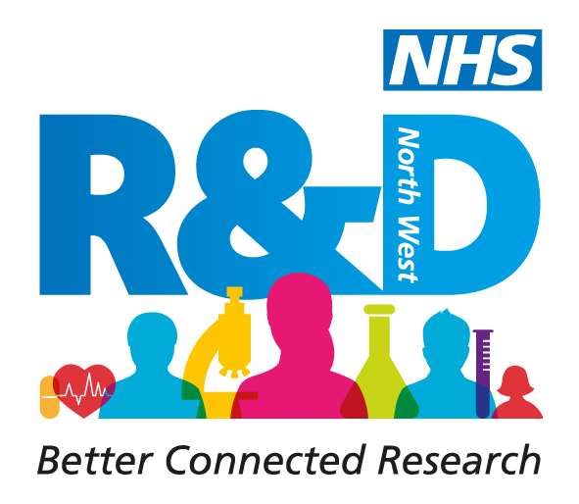
NHS Research & Development North West Conference

Let’s Talk Research 5 – The Time is Now

25th June 2020

Abstract Submission Form for Alternative Format Presentation

The abstract length is limited to a maximum of 250 words. This will be checked and abstracts exceeding this limit will be returned for amendment.

Please indicate the format of your presentation;

SHORT FILM/PHOTOGRAPH/ARTWORK/INFOGRAPHIC/POSTER/E-POSTER/INTERACTIVE POSTER

OTHER (PLEASE SPECIFY) …………………………………………………………………….

Complete all text within the clear boxes provided in 12pt Arial.

Name of person submitting the abstract:
First |  |  |  | Last |  | Title
Affiliation(s) e.g name of employing organisation, university

Names of additional author(s) and their affiliations |  |  | 1. Name:  Affiliation:
2. Name
Affiliation
3.Name
Affiliation
4. Name
Affiliation
5. Name
Affiliation
Name of presenting author
If presenting a research study was the research undertaken as part of an (please tick)

MSc Yes No
PhD Yes No

Other (please explain)

Title
Abstract (250 words maximum). This is an expandable box and will accommodate the word limit.

Keywords (maximum 3)
References (maximum of 3)

The deadline for submitting abstracts is 5pm Tuesday 30th June 2020.

Please submit completed forms to: Leanne.gregory@researchnorthwest.nhs.uk

