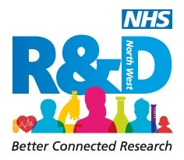

Leading Cultures of Research and Innovation: a leadership development programme.
**Please note this is open to North East and North Cumbria only!**

Title

First name

Surname

Home Address (for venue purposes)
Job title

Employing organisation
Contact telephone number
Email

Please describe briefly the service you lead and the numbers of people in your team (max 200 words)

Why are you interested in participating in this programme?

What are the three key things you hope to achieve as a consequence of participating?
Dates

24th and 25th September 2019 two day residential – top secret location!
24th October one day workshop Location TBC
20th November one day workshop Location TBC

Please note you need to be able attend all four days to be eligible for this course and the course is open to staff working in the North East and North Cumbria

We will be developing an on-line community as part of this programme. Please can you indicate which platform you would prefer to use:- (highlight preferred option)

Facebook Google Plus WhatsApp Slack LinkedIn Other (please state)

Do you have approval from your line manager to attend this programme? | Yes No (please circle as appropriate)

Please return to Leanne.gregory@researchnorthwest.nhs.uk

The closing date is 5pm Wednesday 31st July 2019

