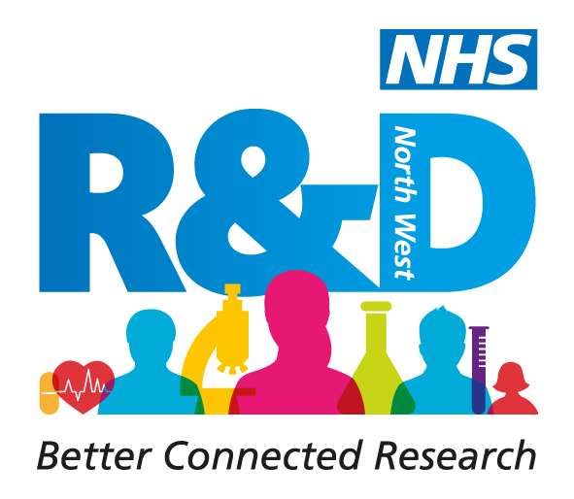
Using Social Media to support research

The use of social media in supporting and facilitating research networks and as an integral part of the research process is increasing. The“Power in Your Pocket” workshop at our Lets Talk Research conference generated a great deal of interest and to develop this work we are running a programme of linked workshops to support the development of a community of researchers who can take advantage of the technology available to them to support their research and develop networks.

Who should apply?

We are seeking people working as part of the NHS research community in the NW who want to develop their skills and expertise in using social media. You must be able to attend both workshops and be committed to, between workshops, applying your learning to participate in twitter chats which will be open to the wider research community. It is important to note that this programme is about working with us to build a social learning research community as well as developing your own skills.

Workshop 1 – Social Media the Basics

This session will take the group beyond social media for personal use into the facilitation of learning and sharing networks and communities. Its focus will be on:
- Twitter & advanced social media tools (scheduling tweets & twitter to
support networks)
- Getting involved in (and facilitating) conversations e.g. twitter chats
- Capturing and sharing content (curation) using Storify, slideshare,
Pinterest, Scribd etc)

The group will be challenged to participate in twitter chats to explore the potential impact of social media and technology on their research work.

Workshop 2 – Curation, Evernote and Workflows

One of the challenges we all face in using social media is the ability to develop an effective system for locating all the gems of information we find. This session will help you to build powerful workflows and personal curation systems to capture, store and retrieve online research and information effectively.

